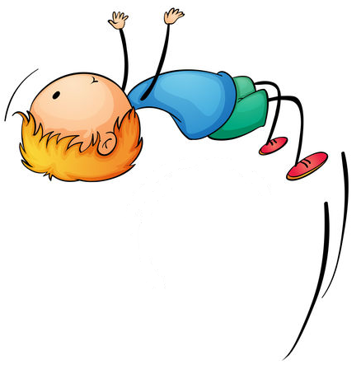
LEGO
Play Box
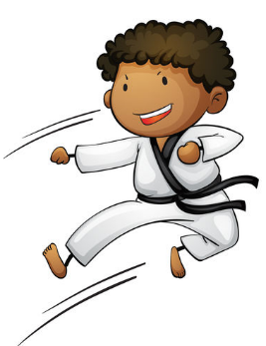
Fun & Games

Written in partnership with
Contents:

Understanding the LEGO Bricks ….2
Brick Bingo ….3
Can it Fly? ….4
Dice and Stack ….4
Brick Battleships ….5
Hanging Around ….6
LEGO Jar Guessing Game ….7
Maze Fun ….7
Tower Build ….7
Finger Twister ….8
Peg LEGO Race ….8
Team Challenge ….9
Scavenger Hunt ….9
Kim’s Game …10
Spot the Difference …10
Puppets …10
Car Race …11
Brick-O …11
LEGO and Spoon Relay Race …12
Pencil Golf …12
Bowling …13
Brick Slide …13
Photocopy page: Finger Twister …14
Photocopy page: Battleships …15
Photocopy page: Bingo …16

Understanding the LEGO Bricks
Introduction: Each of the LEGO pieces has a special name. It is helpful for you to know these names as they are referred to in many of the activities that follow.

Minifigure
Parts

Plates

Minifigure Accessories
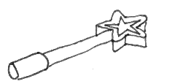
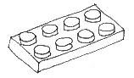
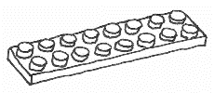
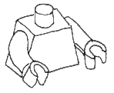
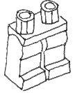
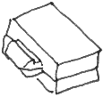
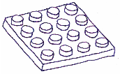
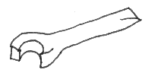
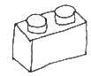
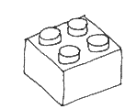
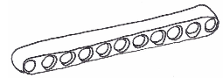
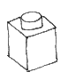
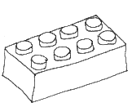
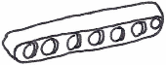

Beams

Bricks

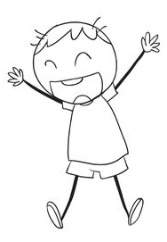
Brick Bingo
BINGO
Equipment needed: All of the LEGO
How the game works:
- Give each student a baseplate or one of the Bingo
templates provided (photocopy page)

- Each student chooses 25 different (they can be the same shape but different colours) LEGO pieces and places them in five horizontal and vertical rows as in the example shown below:

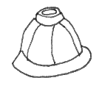
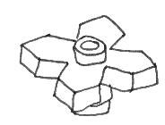
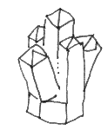
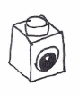
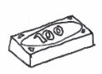
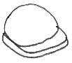
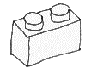
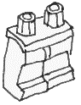
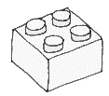
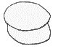
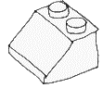
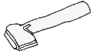

- Teacher puts as many different LEGO pieces as they can find into a bag

- Each round, the teacher pulls out a piece, shows it to the class, and then names or describes it (e.g. blue two by four)

- If the student has that piece on their board, they can remove it and place it to one side

- When a student has removed 5 in a row (horizontal or vertical) they shout “Bingo”

- You can continue playing until someone has finished their whole board, or start again

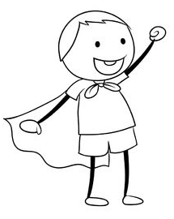
Can it Fly?
Equipment needed: String, paper or fabric and LEGO bricks
How the game works:
- Students are divided into teams

- Each team is given string and paper which they use to make a parachute

- Give each team the same selection of LEGO bricks

- Teams need to build structures that can be tied to the parachutes, and will not break on landing

- After all the teams have built their structures, test them by throwing them from a high place (e.g. staircase, tree, second storey window - you may need to take the class outside to do this)

- If none of the structures break, if possible, increase the difficulty of the task by throwing them from a greater height, until you only have one unbroken structure left

- The last team left with an unbroken structure is the winner

- To add to the game, give each team a minifigure and tell them to build a structure that will keep the minifigure safe when it lands
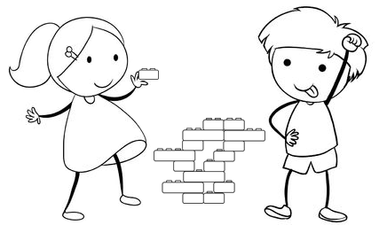
Dice and Stack
Equipment needed: Two dice and thirty 2 x 4 LEGO bricks for each group
How the game works:
- Students work in groups of 4 – 6 and take turns to throw two dice and then place two bricks on a communal build

- The sum of the numbers shown on the dice must be the number of studs that are left open on the top of the communal build

- The game begins with two bricks placed next to each other in the middle

- When building each level, the students must keep the stack balanced so that it does not fall

- If a student cannot cover the studs correctly then he / she is out and the game continues with the remaining students

- For example:
  - First student throws dice and they land on 4 and 3
  - Student takes 2 bricks and adds a new level to the bricks in the middle, leaving 7 studs open
  - Second student throws dice and they land on 2 and 6
  - This student takes another two bricks and adds another level, leaving eight studs open
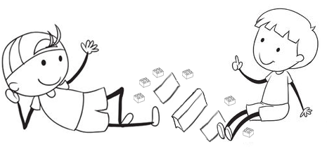
Brick Battleships
Equipment needed: Battleships grids (photocopy page) and 2 x 2 LEGO bricks of various colours
How the game works:
- Battleships is a guessing game for two people which was first played in World War I

- You can play this game as part of a history lesson on WWI, or a maths or geography lesson

- Give each student a page with two battleships grids. The grid provided here is an alpha-numeric version but there are x-y versions and mini grids available in the maths booklet.

- Each pair sets up a screen (e.g. an A4 book) between the two participants

- Students place 7 ships (coloured bricks in vertical or horizontal rows) on the grid on the left of the page, as shown in the example below. The ships may not touch sides with one another.

 | A | B | C | D | E | F | G | H
1
2
3
4
5
6
7
8
e.g.
Key:
Aircraft carrier – 5 bricks
Battleship – 4 bricks
Cruiser – 3 bricks
Destroyer – 2 bricks
Submarine – 1 brick

- Players take turns to guess the location of the ships on their opponent’s grid (1 block per turn) by giving the co-ordinates of one of the blocks (e.g. A3)

- The opponent announces whether each guess is a “hit” (i.e. there is a brick in the block guessed) or a “miss” (i.e. no brick in the block guessed)

- The opponent removes any bricks that get hit

- Players use the grid on the right to mark hits (red bricks) and misses (white bricks)

- When a complete ship has been hit, the opponent announces, “You sank my battleship”

- The winner is the first person to sink all of their opponent’s ships
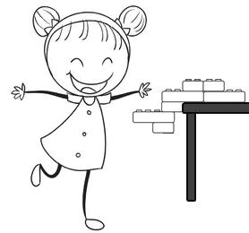
Hanging Around

Equipment needed: Twenty 2 x 4 LEGO bricks for
each pair of students

How the game works:
- Students see how many bricks they can hang off the edge of a desk

- Start with three 2 x 4 bricks, joined together, and going off the edge of the table like this:

- Students continue adding bricks to the model the overhanging one, deciding where to add each new brick in order to balance the model on the edge of the desk

- After the activity, ask:

  - How many bricks did you need on top of the table to balance your model?

  - What is the least number of bricks you would need to put on top of the table, if you were to build a model out of all twenty bricks?
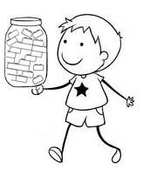
LEGO Jar Guessing Game
Equipment needed: Jar and LEGO bricks
How the game works:
- Fill a jar with LEGO bricks

- Each person has a chance to guess how many bricks are in the jar

- The person who’s guess is closest to the correct number wins
Maze Fun
A-MAZE-ING!
Equipment needed: LEGO bricks and a baseplate for each student
How the game works:

- Each student uses bricks to build a maze on their baseplate

- Students pass their baseplates to classmates and each student is given a minifigure

- Each student needs to complete the maze in front of them by moving his or her minifigure from the start of the maze to the end

- Once a student has finished a maze, they trade with someone else in the class and then try to complete the new maze

- Students can continue trading until one person has completed them all

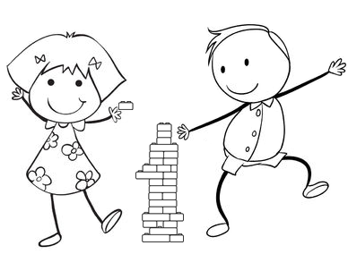
Tower Build
Equipment needed: LEGO bricks and baseplates
How the game works:
- Students work in teams to see which team can build the tallest tower in ten minutes

- Towers must be free-standing (i.e. students cannot hold them up)

- The tallest free-standing tower at the end of the ten minutes is the one that wins

- To add an extra challenge to the game, include a contest for strength (which could be tested by blowing the towers or tilting the baseplates to see which ones fall first)
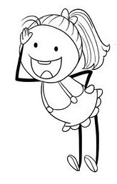
Finger Twister
Left thumb red
Equipment needed: Dice, baseplates and 2 x 2
LEGO bricks of different colours

How the game works:
- Students play in groups of 3 or 4

- Each team builds a mini Twister mat by placing four rows of six different coloured bricks across the baseplate (i.e. 6 red bricks in a row, 6 yellow bricks in a row etc.)

- Students can construct the spinner on the photocopy page or use two dice instead

- Choose one person to be the dice roller or spinner

- The first student spins or rolls and then places their fingers on the LEGO bricks as follows:

First die: Second die:
1 – Left thumb 1 - Blue
2 – Left index finger 2 - Red
3 – Left pinky 3 - Green
4 – Right thumb 4 - Yellow
5 – Right index finger 5 –Fist bump the spinner!
6 – Right pinky 6 – Choose your colour!

- When a player’s hand collapses, they are out, and play continues without them

- The last player left “standing” is the winner

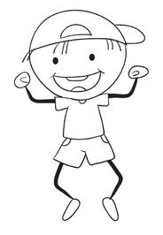
Peg LEGO Race
Equipment needed: Clothes pegs and LEGO bricks
How the game works:
- Put all the LEGO out on mats or blankets on the floor

- Give each student a peg

- Divide the students into 4-6 teams and allocate a brick colour to each team

- Teams race to see who can collect the most bricks (of allocated colour) in a given time period, using only the pegs (i.e. no hands) to pick up the bricks
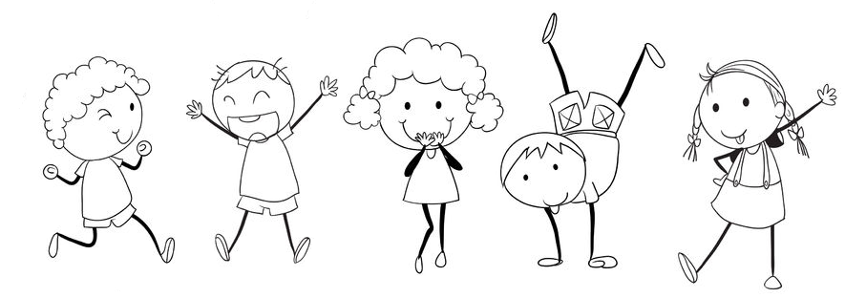
Team Challenge
Equipment needed: Pieces of fabric and LEGO bricks
How the game works:
- Divide the students into teams of five

- Each of the students is given a “disability”:
  - First student has their hands tied behind their back
  - Second student has a blindfold on
  - Third student is not allowed to speak
  - Fourth student wears earplugs (or covers their ears with their hands)
  - Fifth student has their legs tied together

- Teams need to work together to build a copy of a simple model which you have built beforehand

- The model can be placed on a desk in front of the class or you can hide it behind a screen and only the person with their hands tied is allowed to come and see it

- The team that correctly builds the model first is the winner

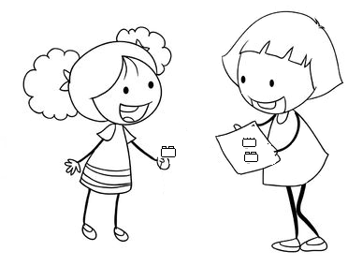
Scavenger Hunt
Equipment needed: All of your LEGO
How the game works:

- Before the game, choose 10-20 different LEGO pieces and stick them on to a baseplate

- Include some pieces that will be easy to find and some that will be difficult (but make sure you at least have enough of each piece in your LEGO for each group to find one)

- Put all the LEGO out on mats or blankets on the floor

- Divide students into teams and give each team a baseplate

- Teams search through the LEGO to try and find all the pieces on the baseplate

- The team with the most matching LEGO pieces after 10 minutes is the winner

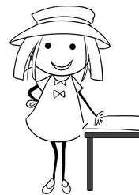
Kim’s Game

Equipment needed: A selection of different LEGO pieces and a baseplate

How the game works:
- Teacher chooses ten LEGO bricks and joins them to a baseplate

- Teacher holds the baseplate up for the class to see

- Teacher covers the baseplate with a cloth, and removes one of the pieces without letting the students see

- Teacher removes the cloth and students try to identify which pieces has been removed

- The game continues until all the pieces have been removed

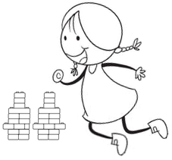
Spot the Difference

Equipment needed: All of the LEGO

How the game works:

- Each student builds two small models that are identical except for one thing

- Model pairs are placed around the class

- Students move from station to station, writing down the difference they notice between the two models at each station

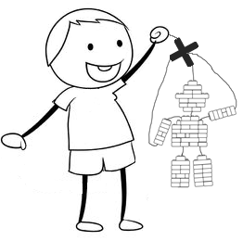
Puppets

Equipment needed: String, sticks and LEGO bricks

Activity:
- Students build marionette puppets using LEGO bricks and string

- The head, body, legs and arms should be made out of bricks

- These should be joined together with pieces of string that are clipped between two of the bricks to hold them in place

- Attach extra pieces of string to the head and arms and tie these to sticks above the puppets

- Students move the puppets by moving the sticks up and down

- Once the students have made their puppets, let them tell stories using the puppets

- For an extra activity, get them to design and make puppet stages out of LEGO bricks
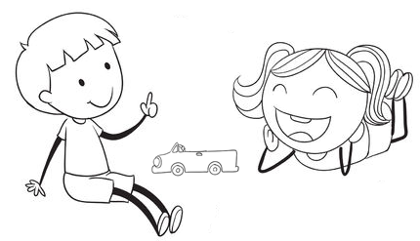
Car Race
Equipment needed: Wheels, axles or wheels holders, and a variety of LEGO pieces
How the game works:
- Put all the LEGO out for students to use

- Divide students into teams and give each team four wheels and axles

- Teams need to design and build a car within a specified time period

- When the time is up, find a smooth (and preferably sloped) surface to race the cars on

- Teams take turns pushing their cars from behind a line

- The car which goes the furthest is the winner

- You can add a second stage to the game by giving each team a load (of bricks) that their car needs to carry and allowing them time to adjust the car accordingly

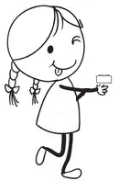
Brick-O
BRICK-O!
Equipment needed: A selection of different LEGO bricks

How the game works:

- This game is similar to the card game “UNO”

- Students play in groups of 2-6

- Place all of the bricks in a bag

- Each student takes a turn to close their eyes and take 8 bricks out of the bag

- Students place bricks behind a screen or in a pencil bag so that other players cannot see them

- Once each of the students have taken 8 bricks, the bag is placed in the centre, and one brick is taken out and placed next to it

- The first player needs to see if they have a brick that matches either the colour or number of studs on the brick in the middle

- If they have a matching brick, they place it on top of the one in the middle

- If they don’t have a matching brick, they take another brick from the bag (with closed eyes)

- The winner is the first person to finish all of their bricks

- Extra challenge: Players need to keep the stack of bricks in the middle standing. If the tower falls over, the player who placed the last brick on it needs to pick up three bricks.

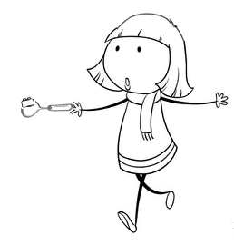
LEGO & Spoon Relay Race
Equipment needed: Spoons and LEGO bricks
How the game works:
- This game is best played in a large room or outdoor space

- Put LEGO into buckets or bowls at one end of the room or space

- Divide the students into teams and give each team a spoon

- The first person in each team runs to the end of the room, picks up a LEGO brick with their spoon and carries it back on the spoon, to their team

- If they drop the brick, they need to go back to the bucket and start again

- As each runner returns to their team, they pass the spoon to the next person who runs to the bucket and picks up another brick

- Teams continue to pick up and carry bricks back in relay until they have a certain number of bricks (or a certain amount of time has passed)

- The team with the most bricks is the winner

- Extra challenge: Build a simple structure out of bricks and take a photo of it. Teams need to build the structure out of bricks which they have collected from the bucket, in order to win the game.

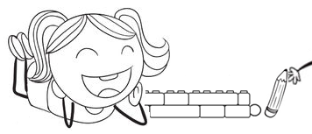
Pencil Golf

Equipment needed: Pencils, marbles and all of the LEGO

How the game works:
- Students work in groups to build a “hole” for a tiny miniature golf course out of LEGO

- Each “hole” needs to have a tee-off point, a wall to enclose the space (this can just be two bricks high) and a receptacle which the marble needs to finish in

- When the “holes” are finished, lay them on the floor of the classroom and number them

- Groups take turns playing at each “hole” to see how many pencils strikes it takes each of them to get the marble into the receptacle

- They can keep score and the winner is the person who has the lowest total once the group has played all of the “holes”

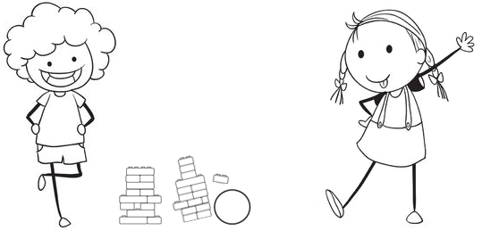
Bowling
Equipment needed: Balls, fifteen 2 x 4 LEGO bricks and fifteen 2 x 2 LEGO bricks for each student
How the game works:
- Each student builds a skittle using the bricks they have been given

- The skittle must be able to fall over when the ball hits it, but must not break apart

- Students test whether the skittles fit these specifications by rolling balls at them from a certain distance which the class agrees upon together

- After all the skittles have been tested, use them to make a bowling alley (i.e. a space where students can roll a ball towards 10 skittles, to see how many they can knock over)

- Groups of students take turns bowling against one another
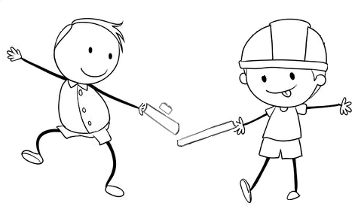
Brick Slide
Equipment needed: A ruler for each student and a 2 x 4 brick for each group
How the game works:
- Students work in teams of 4 to 6

- Each student has a ruler in their hand

- The game is a relay in which each member of the team must slide a brick down their ruler and pass it on to the ruler of the next student without touching the brick

- If the brick is dropped at any stage in the relay, then the team must begin again

Finger Twister: Photocopy page

RIGHT
RIGHT
LEFT
LEFT
Twister Spinner Instructions:
1. Photocopy the template on the left

2. Colour the circles in red, yellow, green & blue (one of each colour in each section)

3. Use the instructions below to turn the template into a spinner with LEGO pieces (if you don’t have these pieces in your box, you can use dice instead)

How to Make a Spinner out of LEGO:
1. Place a square of paper (you can use the Twister template above or design your own for another game) on a 16 x 16 stud baseplate.
2. Place thin (1 stud wide) bricks or plates along the edge, clipping the paper to the baseplate
3. If you can find the pieces to make a small turntable, click these pieces on to the middle of the paper and baseplate and attach a 3 x 1 or 4 x 1 plate to turn it into a spinner.
4. If you cannot find the pieces for a turntable, you can try designing your own spinner using cardboard and a split pin, or use dice instead.
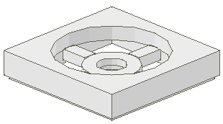
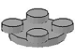
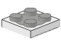
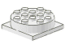
Some examples of
turntable pieces:

Battleships: Photocopy page
Brick Battleships
Your Ships Enemy Ships

 | A | B | C | D | E | F | G | H |  |  | A | B | C | D | E | F | G | H
1 |  |  |  |  |  |  |  |  |  | 1
2 |  |  |  |  |  |  |  |  |  | 2
3 |  |  |  |  |  |  |  |  |  | 3
4 |  |  |  |  |  |  |  |  |  | 4
5 |  |  |  |  |  |  |  |  |  | 5
6 |  |  |  |  |  |  |  |  |  | 6
7 |  |  |  |  |  |  |  |  |  | 7
8 |  |  |  |  |  |  |  |  |  | 8

Aircraft Carrier – 5 bricks Battleship – 4 bricks Cruiser – 3 bricks
Destroyer – 2 bricks (x2) Submarine – 1 brick (x2)
Bingo: Photocopy page

