LEGO
Play Box
Mathematics

Written in partnership with

Contents:

Teaching Maths with LEGO ….2
Web Links ….3
Factors and Multiples ….4
Square Numbers and Cube Numbers ….6
Fractions ….8
Patterns and Sequences …10
2D Shapes …13
Points of View …15
Symmetry …16
Transformations …19
Perimeter and Area …22
Volume and Surface Area ...24
Data Handling ...26
Maths Game I: Twenty-Four ...29
Maths Game II: Dice & Stack ...30
Maths Game II: Battleships ...31
Maths Game IV: Brick Equations …33
Shoot for a Shape …34
Photocopy page: Data handling …35
Photocopy pages: Battleships …36
Photocopy page: Brick Substitutions …39
Photocopy page: Shape Game Cards …40

Teaching Maths with LEGO
An Introduction
Why use manipulatives to teach maths?
I hear and I forget.
I see and I remember.
I do and I understand.
—Confucius (551–479 BC)
Manipulatives are concrete objects that students can see, touch and manoeuvre in order to model or show abstract concepts. Over two hundred years of research has shown that manipulatives are vital for the development of children and make a significant contribution to a student’s understanding of mathematical concepts. Manipulatives give students the opportunity to construct their own cognitive models for abstract mathematical ideas, and they also help keep students interested and engaged, both of which have a direct link to increased mathematical ability.

What LEGO pieces will I need to teach maths?
Most of the maths activities here make use only of bricks and plates and not the minifigures and accessories. You may want to remove the minifigures etc. from the LEGO you use for your maths classes as they may be distracting to the students (however, they are great to use for language activities or free play). Most of the activities make use of 16 x 16 baseplates for the students to build on. However, if you cannot find enough of these in your charity box, you can use different sized baseplates. It would be helpful if each student had the same sized baseplate (even if it means joining a few smaller ones together).

What grades are these activities designed for?
These activities are designed for grades 4 -9. Most of these activities and investigations have been designed as an introduction to a particular topic. However, you can easily adapt them for a more or less advanced lesson for use at any grade level. Once you start using the bricks for maths, you will find that the possibilities for using them are almost endless! We encourage you to use the activities in this book as a springboard for your own ideas.

Who is this book for?
This book has been designed for use by teachers. There are a few photo copy pages which can be used as student hand-outs, but the rest of the content is for use by the teacher. The diagrams are not intended to be photocopied and given to the students, as they can usually be replaced by 3D LEGO brick models (which are far more effective teaching tools) which you can build before the lesson and use as examples or demonstration models if needed.

Web links to (even more!) LEGO lesson ideas:
- www.tes.com/teaching-resource/
  - Probability with Lego Men 6408203
  - Lego Man Multiplication 11084019
  - Lego Measuring Game 6420438
  - Intro to Fractions using Lego 11035601
  - Lego Men Probability 6435080
  - Lego Movie Tally, Frequency and Block Graph 6408772
  - Lego Word Problems 6439653

- www.scholastic.com/teachers/top-teaching/2013/12/using-lego-build-math-concepts
  - Part-Part-Total
  - Multiplication and Division
  - Equivalent Fractions
  - Mean, Median, Mode and Range

- www.teacherspayteachers.com
  - Lego Lab Math 1-2-3 Furniture Market Problem Modeling 1515935
  - Algebra Game Algetropolis Combining Like Terms Game 323129
  - Awesome Arrays Building Blocks to Multiplication 1877278
  - The Builders Portrait Project Fractions Area Perimeter 1757276
  - The Tutor House - Brick ratios

- eisforexplore.blogspot.co.za/2012
  - Lego Geometry (Area & Perimeter)
  - Lego Bullseye (Place Value)

- colintgraham.com/mathematics/activities-and-resources/101-manipulative-lessons-with-lego/

- sciencekiddo.com/lego-math-place-value/?m=0

- milkandcookiesblog.com/lego-math-for-elementary-school/

- reallifeathome.com/double-digit-addition-and-subtraction-with-lego-bricks/

- corkboardconnections.blogspot.co.za/2013/09/placevalue.html

- frugalfun4boys.com/2014/01/02/math-legos-3-d-multiplication-graph-activity/

Factors & Multiples
CAPS alignment:

Phase | Grades | Content area | Topic
Intermediate Phase | Grade 4-6 | 1. Numbers, operations & relationships | 1.1 Whole numbers (factors & multiples)
Senior Phase | Grades 7-9 | 1. Numbers, operations & relationships | 1.1 Whole numbers (factors & multiples)

LEGO needed: Different sized bricks.

Investigation:
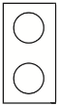
- Use the two by one bricks to count in twos:

2, 4, 6, 8, 10, 12 etc.
- How many bricks did you use to count to 10? 20? 24?
- How many bricks would you need to count to 100?

- Now use the two by two bricks to count in fours:

4, 8, 12, 16 etc.
- How many bricks did you use to count to 20? 24?
- How many bricks would you need to count to 100?

- Now use the two by four bricks to count in eights:

8, 16, 24 etc.
- How many bricks did you use to count to 24?

- What do you notice about the number of bricks you used to count to 24 each time? Try to write these as multiplication sums.

e.g. 12 x 2 = 24

e.g. 6 x 4 = 24

e.g. 3 x 8 = 24

- Use all of your bricks to build a wall. The wall should be built with two by four bricks on the bottom layer, two by two bricks on the next layer and two by one bricks on the top layer. What do you notice?
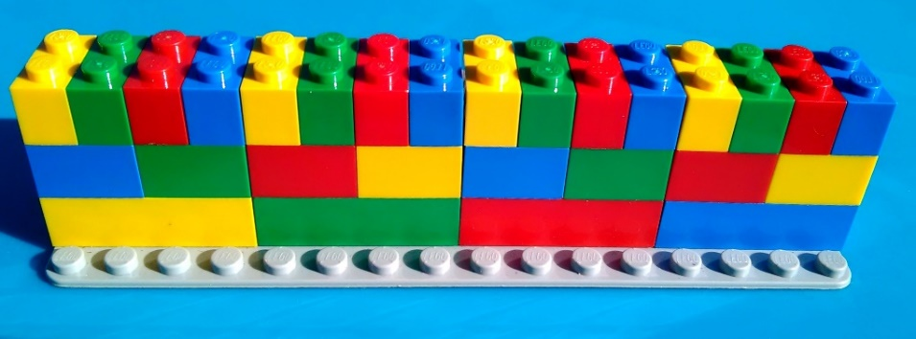

- Does the wall all stay together? Where does the wall break?

- What does this tell you about the relationship between the numbers 2, 4, 8 and 24?
2, 4 & 8 are factors of 24.
24 is a multiple of 2, 4 & 8.

2 & 4 are factors of 8.
8 is a multiple of 2 & 4.

2 is a factor of 4.
4 is a multiple of 2.

- Can you think of any other numbers that are factors of 24?

- Can you think of any other numbers that are multiples of 8?

Square Numbers and Cube Numbers
CAPS alignment:

Phase | Grades | Content area | Topic
Senior phase | Grades 7-9 | 1. Number operations and relationships | 1.2 Exponents

LEGO needed: A selection of different sized LEGO bricks and a baseplate for each student.

Investigation:

  - Tell the students to each take one 2 x 2 brick and place it on their baseplate.

    - How many studs are there on this brick?
    - If you took the number four and multiplied it by itself, what would the result be?

  - Tell the students put four 2 x 2 bricks next to one another in the shape of a square to represent four multiplied by four.

    - How many studs are there altogether on these four bricks?
    - If you took the number sixteen and multiplied it by four, what would the result be?
    - What shape would you build the bricks in to represent this?

  - Tell the students to build sixteen 2 x 2 bricks in four layers to make a cube-like* shape, which could represent sixteen multiplied by four.
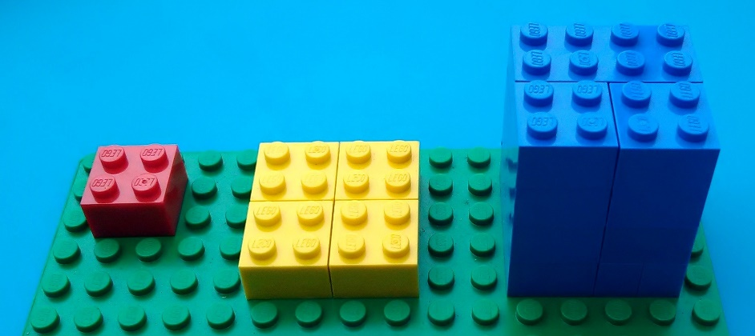

4 ${4 ×4=4}^{2}$ ${4 ×4 ×4=4}^{3}$

* This shape is actually a rectangular prism, not a cube, because the height of a 2 x 2 LEGO brick is not the same as the length of its sides. But, because it is helpful to use the word “cube” to show the relationship between the shape and a cube number, we suggest using the word “cuboid" which comes from the word "cube" and -oid (which means "similar to, or resembling").
  - Show the students a demonstration model of the three numbers. Explain that the number sixteen (represented by the second model) is called a square number and the number sixty-four (represented by the third model) is called a cube number.

    - Why do you think 16 is called a square number?
    - What number is 16 the square of?
    - Why do you think 64 is called a cube number?
    - What number is 64 the cube of?

  - Write ${4 ×4=4}^{2}$ and ${4 ×4 ×4=4}^{3}$on the board to show the students how a square number and a cube number are represented in numeric form. Place your demonstration models next to the correct formulae.
Further investigation:
  - Write the following three sequences of numbers on the board and ask the students to choose one sequence to build using LEGO bricks:
    - 2, $2^{2}$, $2^{3}$
    - 6, $6^{2}$, $6^{3}$
    - 8, $8^{2}$, $8^{3}$

  - When the students have finished, tell them to show their models to a partner and discuss why they have represented these numbers in this way.

  - Now tell the students to form groups of four and combine their models in different ways to write addition number sentences. Get the groups to come and write their number sentences on the board for other groups to work out.
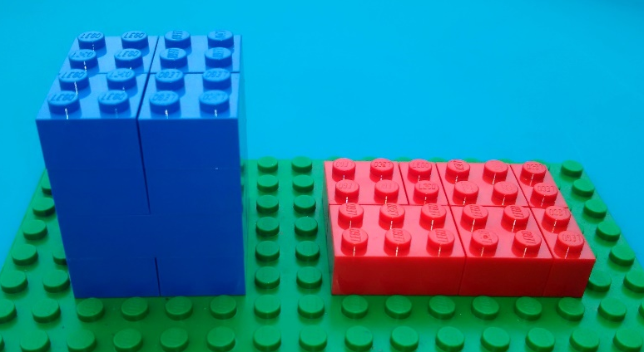

e.g. $4^{3}+6^{2}$

- Which numbers or models were easy to add together?
- Which numbers or models were difficult to add together?
- Which of the following are you able to simplify?:

  - $x^{3}+y^{2}$
  - $x^{3}+y^{3}$
  - $x^{2}+x^{2}$
Fractions
CAPS alignment:

Phase | Grades | Content area | Topic
Intermediate Phase | Grade 4-6 | 1. Numbers, operations & relationships | 1.2 Common fractions
Senior Phase | Grades 7-9 | 1. Numbers, operations & relationships | 1.4 Common fractions

LEGO needed: Baseplates and various sizes of bricks
There are many different ways to use LEGO bricks to represent fractions. Below are a few examples of these. You can also ask your students to see if they can come up with their own ideas.

- Using bricks: Put six bricks of the same size next to each other to make a big rectangle. Pretend the rectangle is a cake. Use a ruler to cut your cake in half and take half of the bricks away to show that they have been eaten.
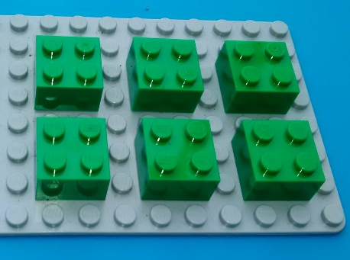
- How many bricks do you have left?

- Now cut your cake into thirds. How many bricks do you have?

- Can you convert the thirds into sixths?-

- Now try doing the same thing with just 4 bricks. Can you convert the halves into quarters?

- Using circular plates: If you have quarter-circle, semicircle or circular plates in your LEGO Charity Box, you can also use these to represent fractions.

- Using the studs: Put one brick on top of another. The studs on the bottom brick represent the denominator and the studs on the top brick represent the numerator. You can also use plates if you want to represent fractions with large denominators.

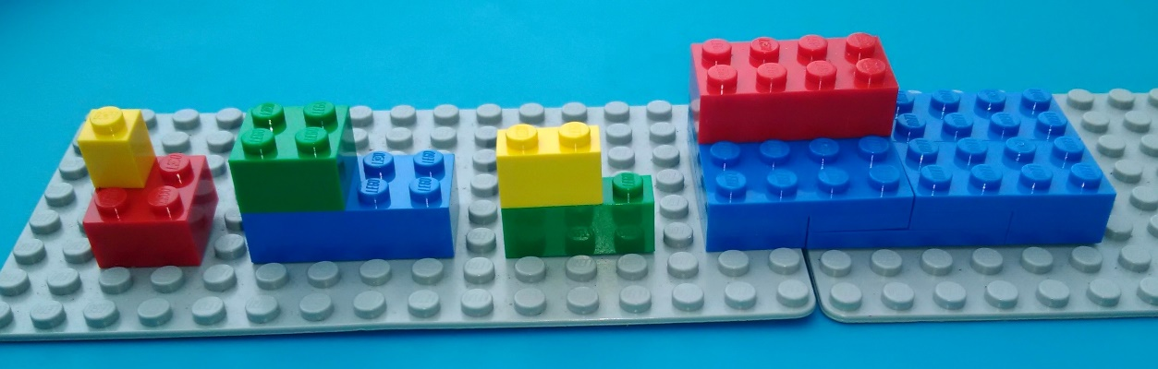
e.g.

$\frac{1}{4}$ $\frac{4}{8}$ $\frac{2}{3}$ $\frac{8}{32}$

- Adding and subtracting fractions (from Grade 5 only): You can add bricks to show how to change fractions into equivalents (i.e. with the same denominator) so that they can be added or subtracted from one another.
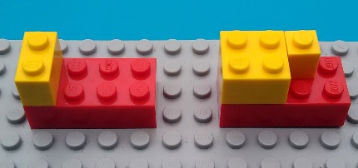
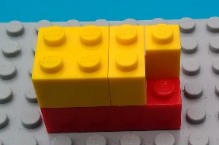
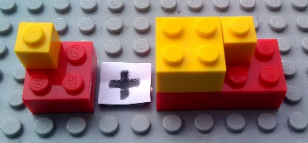
e.g.
+
+
= =

$\frac{1}{4}$ + $\frac{5}{8}$ = $\frac{2}{8}$ + $\frac{5}{8}$ = $\frac{7}{8}$

Once the denominators are the same, show the students how the numerators should be added together by moving the brick(s) on top of one of the fractions to the top of the other fraction. Once they have been moved, remove the brick that was underneath from the board and put it away.
e.g.

Patterns and sequences
LEGO bricks are great to use for building patterns and there are many different activities you could do around this topic. Below are a two examples of activities – the first is a fairly basic one for a primary school class, and the second is for a more advanced high school lesson.

LEGO needed: LEGO bricks and baseplates

Activity 1: Patterns and sequences

CAPS alignment:
Phase | Grades | Content area | Topic
Intermediate Phase | Grades 4 - 6 | 2. Patterns, functions & algebra | 2.1 Numeric patterns  2.2 Geometric patterns
Senior Phase | Grades 7 - 9 | 2. Patterns, functions & algebra | 2.1 Numeric patterns  2.2 Geometric patterns

- Show the students a few examples of patterns or sequences you have built out of LEGO bricks
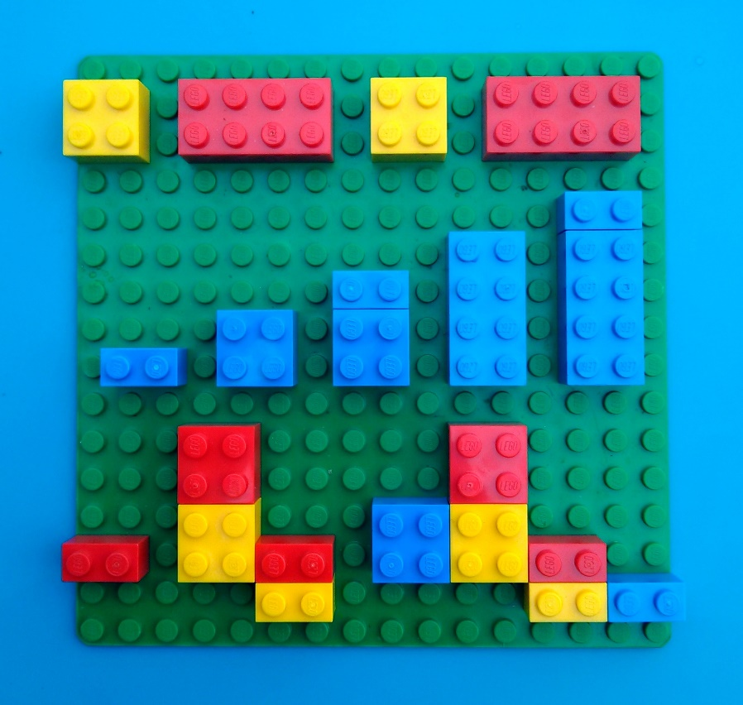
e.g.

- Tell the students that they need to build a sequence or pattern on their baseplate. A sequence is list of numbers or objects in a special order. They can use any of the bricks and build the pattern in any way they want to.

- Tell the students to trade baseplates with someone else in the class

- Ask them to write down the answers to these three questions:
  - What would come next in this sequence? (You can build it first if you need to)
  - Can you write this pattern or sequence down numeric form?
  - Write down a rule to help someone figure out what would go next in the sequence.

- Tell the students to show what they have written down to the person who built the sequence, to see whether they agree with the answers.

- Repeat the exercise with different partners.

Activity 2: Arithmetic, geometric and quadratic sequences.

CAPS alignment:

Phase | Grades | Content area
FET Phase | Grade 10-12 | 2. Number patterns, sequences and series

- Before the lesson, build various different sequences using LEGO bricks and baseplates. Use a different colour for each sequence if possible. As it’s an introductory lesson, we suggest building mostly arithmetic (or linear) sequences and just one or two of the geometric and quadratic sequences. You can use the sequences in the table on the next page if you would like to.

- Draw up a table to record $T_{1}$, $T_{2}$, $T_{3}$, $T_{4}$, the type of sequence, the difference (d) or ratio (r), and the formula for$T_{n}$ and $T_{10}$ (a completed sample table is shown on next page).

- Ask the class what they remember about sequences from previous years and then write the formulae for arithmetic, geometric and quadratic sequences on the board:

Arithmetic Sequences: $T_{n}$ = $a+\left(n-1\right)d$
Geometric Sequences: ${T_{n} =ar}^{n-1}$
Quadratic Sequences: ${T_{n} =an}^{2}+ bn+c$

- Hand out copies of the table you have drawn up (or get the students to draw up their own).

- Show the students one of the simpler patterns you have built and then use this sample sequence to fill in the first row of the table with the class.

- Give each pair of students one of the LEGO sequences.

- The students need to write down the colour of the bricks and then record $T_{1}$, $T_{2}$, $T_{3}$, $T_{4}$, the type of sequence, the difference (d) or ratio (r), and the formula for $T_{n}$ and $T_{10}$.

- When they have finished with the board, they swap it with a different board until they have used them all and completed the table.

- Extension: Give students LEGO bricks and a building board to build their own sequence. They can add these to their table or swap them with other students to continue the activity.

NOTE: When they get to the geometric and quadratic sequences, the students will probably need help. However, rather than teaching this whole section beforehand, we suggest letting them try and figure out how these work as part of this activity.

Colour | T1 | T2 | T3 | T4 | Type of sequence | Tn | T10
Light Blue | 2 | 4 | 6 | 8 | Arithmetic | Tn = 2 + (n – 1).2 = 2n | 20
Green | 6 | 12 | 18 | 24 | Arithmetic | Tn = 6 + (n – 1).6 = 6n | 60
Blue | 4 | 8 | 12 | 16 | Arithmetic | Tn = 4 + (n – 1).4 = 4n | 40
Brown | 24 | 48 | 72 |  | Arithmetic | Tn = 24 + (n – 1).24 = 24n | 240
Beige | 1 | 3 | 5 | 7 | Arithmetic | Tn = 1 + (n – 1).2 = 2n - 1 | 19
White | 4 | 7 | 10 | 13 | Arithmetic | Tn = 4 + (n – 1).3 = 3n + 1 | 31
Purple | 30 | 36 | 42 | 48 | Arithmetic | Tn = 30 + (n – 1).6 = 6n + 24 | 84
Black | 56 | 48 | 40 | 32 | Arithmetic | Tn = 56 + (n – 1).-8 = 64 - 8n | -16
Yellow | 4 | 16 | 64 | 256 | Geometric | ${Tn=(4)(4)}^{n-1}$ | 1048576
Orange | 3 | 9 | 27 |  | Geometric | $$Tn=\left(3\right){(3)}^{n-1}$$ | 59049
Red | 2 | 4 | 8 | 16 | Quadratic | $$Tn=2n^{2}+ 4n+8$$ | 248

2D Shapes
CAPS alignment:

Phase | Grades | Content area | Topic
Intermediate Phase | Grades 4 - 6 | 3. Space & shape (Geometry) | 3.1 Properties of 2D shapes
Senior Phase | Grades 7-9 | 3. Space & shape (Geometry) | 3.1 Geometry of 2D shapes

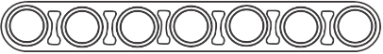
LEGO needed: As many beams and pins as you can find:

Note: Not all of the charity LEGO boxes will contain beams and pins. If your box does not contain any, you can also build most of the shapes out of long bricks (i.e. those that are one stud wide).

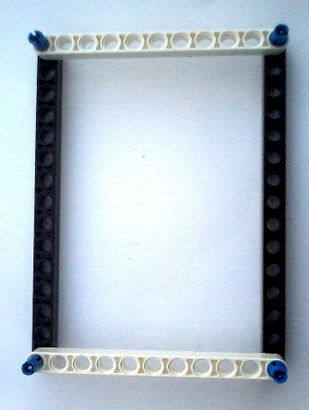
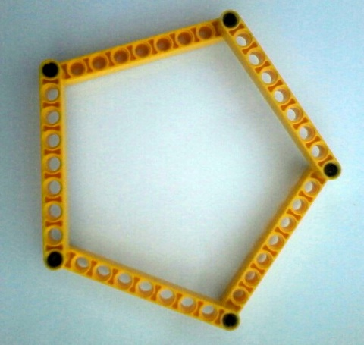
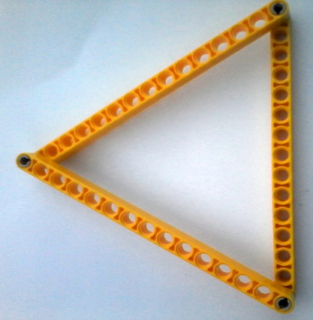
Preparation: Before the class, build a triangle, a square and a rectangle. If you have enough pieces, you can also build a pentagon, a hexagon or some other shapes. If you want to make shapes with equal sides (e.g. a square or equilateral triangle), make sure the beams you use are of equal length.

Class investigation:
- Show the shapes you have made to the class and ask them some questions:

  - What are these shapes called? What helped you decide what their names were?
  - What are the similarities and differences between them?
  - What do we call the corners that are formed between the two sides of a shape?

- Tell the students to use a ruler and pencil to draw different shapes in their books.

- While they are drawing, pass the LEGO shapes around the class. Tell the students to feel the shapes, squash them, move them around in their hands and see what they notice about them.

- When all the students have had a turn to play with the shapes, hold them up and ask:

  - What did you notice about these shapes?

  - What happened to the shapes and the angles when you squashed them?

  - Were there any shapes that you couldn’t squash? Why do you think this was?

  - If we wanted to change the size of the angles of the triangle, what else do you think we would need to change about the shape?

Further investigation:
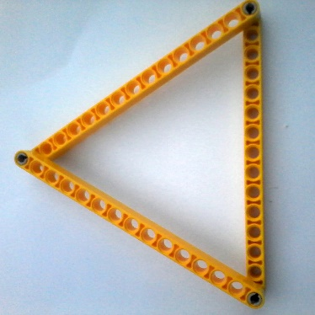
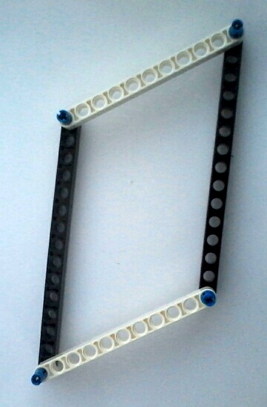
As you ask the questions, squash the square and rectangle to show how the shapes change when you change the angles. Try to squash the triangle to show the students that it cannot change shape. Take the triangle apart and replace one of the beams with a longer or shorter beam.
In a rectangle, all of the angles are right angles (i.e. 90$°$). When you change the size of the angles, the rectangle becomes a parallelogram

A triangle is the only shape where you cannot change the size of the angles without also changing the lengths of the sides.

In a square, all of the angles are right angles (i.e. 90$°$). When you change the size of the angles, the square becomes a rhombus*.

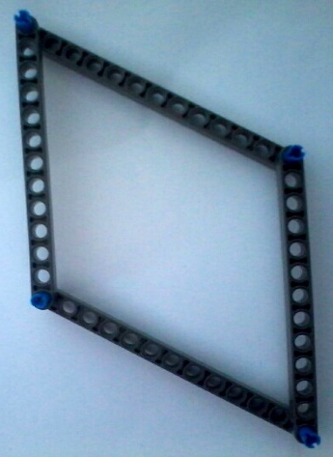
When you make an angle in a triangle smaller, you also have to make the opposite side smaller. So, we can say that there is a relationship between the sizes of the angles and sides of a triangle. This is a very special relationship that only exists in triangles. You will learn more about this relationship later on in high school when you study trigonometry and Pythagoras. When we turn quadrilaterals into triangles to make them stronger, we call this triangulation. You will learn about this in Technology.

Points of View

Phase | Grades | Content area | Topic
Intermediate phase | Grades 4-6 | 3. Space & shape (Geometry) | 3.5 Viewing of objects

LEGO needed: Two 2 x 4 bricks per student
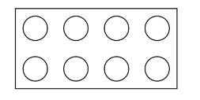
Investigation:
- Put one of your bricks on your desk. Look at it from above. See if you can draw what it looks like. This is called an aerial view.

- Now look at the brick from the side. Make sure your eyes are at the same level as the brick (you can get off your chair if you need to). Draw what you see. This is called a side view.

- Now look at the brick from the front and draw what you see. This is called a front view.

- Join two 2 x 4 bricks together so that the one brick is covering the four studs on the right hand side of the other brick. Look at the pictures below. Which is the aerial view, which is the side view and which is the front view?
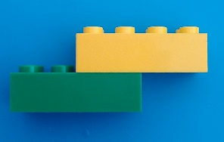
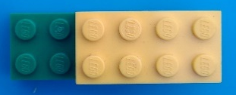

- Join your two bricks together in any way you like and trade bricks with a partner. Draw the aerial view, side view and front view of your partner’s bricks.
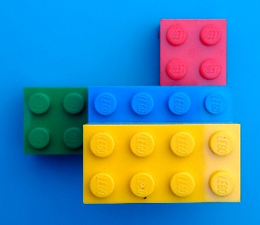
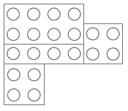
- Work with your partner to see if you can join your four bricks together so that the aerial view will match this one:

Symmetry
CAPS alignment:

Phase | Grades | Content area | Topic
Intermediate Phase | Grade 4-6 | 3. Space & shape (Geometry) | 3.3 Symmetry and 3.4 Transformations
Senior Phase | Grade 7 | 3. Space & shape (Geometry) | 3.4 Transformations geometry

LEGO needed: Square baseplates (preferably of the same size) and various sizes of bricks

- Brick butterflies: You can use this exercise to teach 2D symmetry along the Y-axis.

  - Give each student a baseplate and some bricks

  - Explain that butterfly wings are considered symmetrical because the designs on the two wings mirror one another

  - Help the students to find the middle of their baseplates (i.e. lines of symmetry) by counting the studs, and let them mark it with black LEGO bricks to make the butterfly’s body

  - Students use coloured bricks to design a butterfly wing on the left of the baseplate

  - After they have finished their designs, they trade plates with one another and complete the butterflies by building right wings that mirror the ones on the left

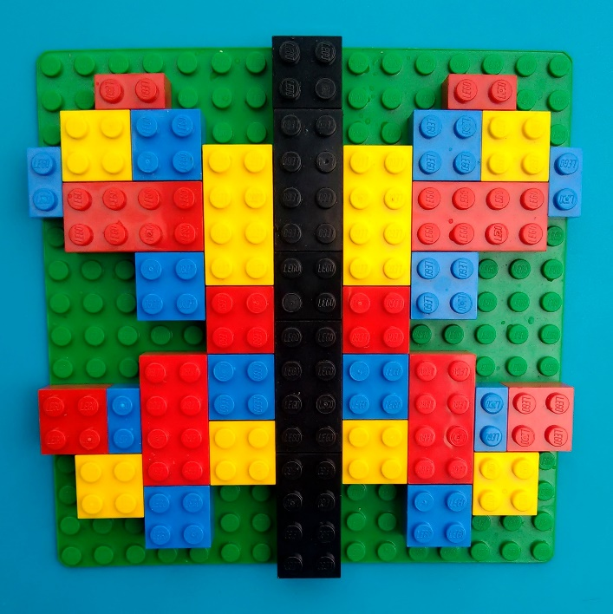
e.g.

- Symmetrical patterns:

  - Give each student a baseplate and some bricks

  - Ask the students how many lines of symmetry there are on a square baseplate

  - Help the students to find the horizontal and vertical lines of symmetry in the middle of their baseplates

  - If they need to they can mark the lines of symmetry with black bricks that are two studs wide

  - Students then use coloured bricks to design brick patterns that are reflected along both lines of symmetry

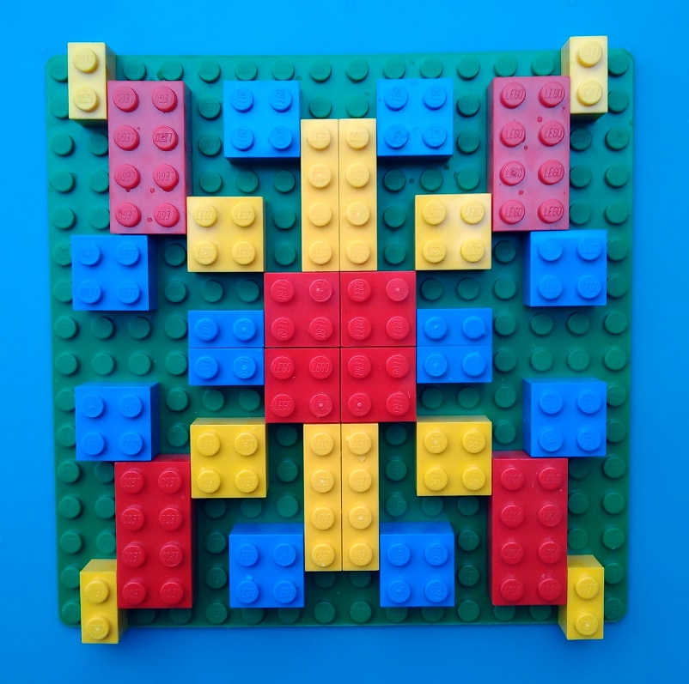
e.g.

- 3D symmetry:

- Tell the students to add layers of bricks to the pattern they made in exercise 1 or 2 to turn the pattern into a 3D pattern

  - Ask the students:

    - If you wanted to add a line of symmetry in a third dimension, where would it fall?

    - How could you use the bricks to represent this?

  - Let the students see if they can reflect their patterns into a third dimension using the bricks

- Lines of symmetry:

  - Before the class, build various symmetrical patterns on square baseplates.

  - Number each of the baseplates (using a piece of paper and sticky tape or prestik).

  - Pass the baseplates around the class

  - For each baseplate, the students need to answer the following questions:

    - How many lines of symmetry are there in this pattern?

    - Where do these lines of symmetry fall? (answer with a sketch of the lines)

  - If it helps the students, they can use pieces of string or the thin edge of a ruler to help figure out where there are lines of symmetry

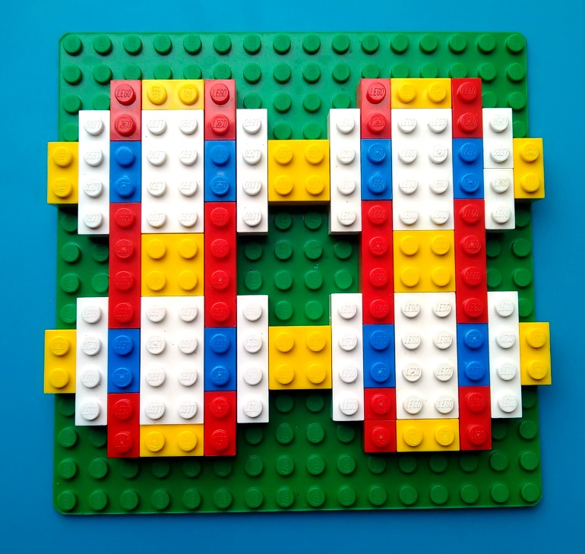
e.g.

Transformations
CAPS alignment:

Phase | Grades | Content area | Topic
Intermediate Phase | Grade 4-6 | 4. Space & shape (Geometry) | 3.3 Transformations
Senior Phase | Grades 7-9 | 3. Space & shape (Geometry) | 3.4 Transformations geometry

LEGO needed: Baseplates and various sizes of bricks

- One brick transformations: You can use this exercise to introduce the topic.

  - Give each student one 2 x 4 brick and a baseplate
  - Tell the students to lay the brick horizontally on the baseplate

  - Explain to the students that there are different ways of moving this brick. We call these transformations. There are three types of transformations we are going to try:

- Rotate (turn)the brick 90$°$ to the right

- Translate (slide) the brick three studs to the left

- Reflect (flip) the brick to the right

  - Students practice using the three different terms, by giving instructions to a partner about how they should move their brick

  - Once they have grasped the concept, they can add in more bricks and practice transforming two or three bricks at a time

- Tessellations:

  - This exercise is similar to the brick butterflies symmetry exercise. However, instead of students reflecting their partner’s pattern across a line of symmetry, they are going to rotate, translate or reflect their partner’s pattern to make a tessellation.

  - Give each student a square baseplate and a selection of bricks.

  - Each student builds a simple pattern in the top left-hand corner of the baseplate.

  - After they have finished their patterns, students trade plates with one another.

  - Give students an instruction for how to transform the pattern (e.g. rotate 90$°$ to the right).

  - Students transform the pattern on their partner’s baseplate according to the instructions (they should leave the original pattern and use new bricks to build the transformed version)

  - Students then trade plates with someone else in the class and transform their patterns according to a new instruction (e.g. translate eight studs downwards).

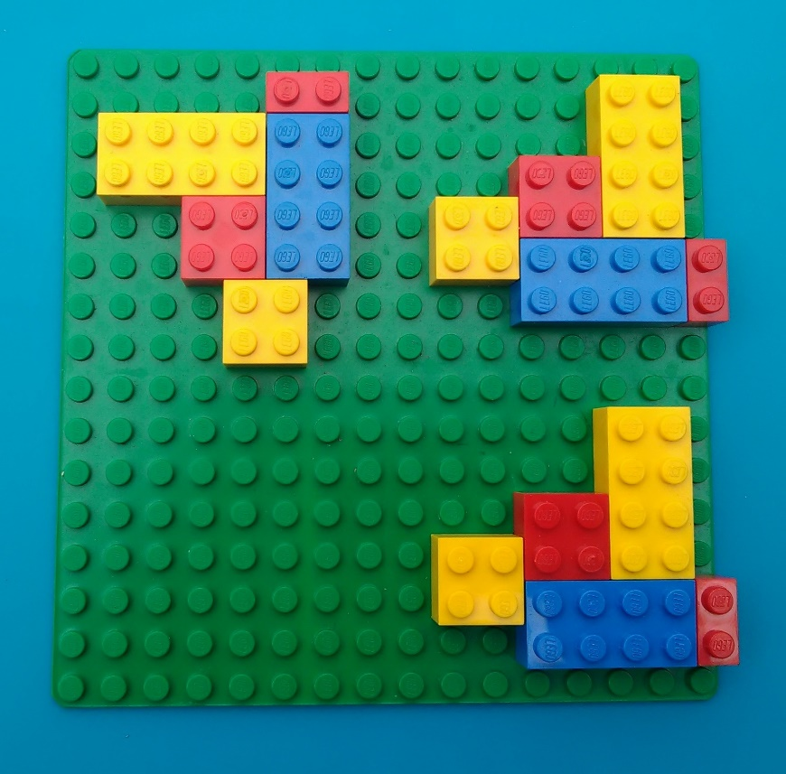
e.g.

- XY Transformations (from Grade 8 only):

  - Use a non-permanent marker and a ruler to draw an x-axis and a y-axis on a square baseplate.

  - Repeat exercise 2 but when you give the instructions for how to rotate or reflect, use the phrases “about the x-axis” and “about the y-axis”.

  - The students then use the axes and the studs to help them build a rotation or reflection of the pattern on their baseplate, according to the instruction given.

e.g. Reflect the pattern about the y-axis

e.g. Reflect the pattern about the x-axis
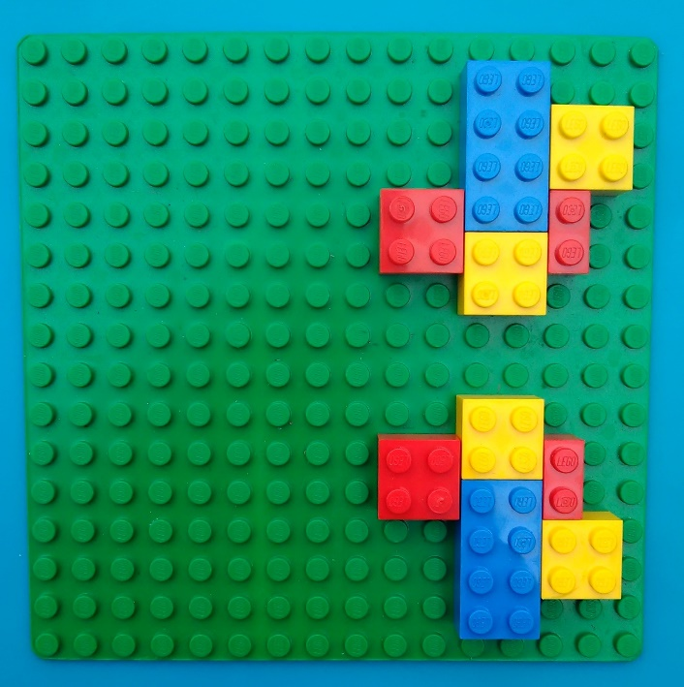

- Once the students have grasped the concept of translating about the axes, take the baseplates away and let them use the Cartesian plane photocopy templates to place their bricks on. Repeat steps b and c, but use co-ordinates on the Cartesian plane to describe how they need to transform their shapes.
Perimeter and Area
CAPS alignment:

Phase | Grades | Content area | Topic
Intermediate Phase | Grades 4 - 6 | 4. Measurement | 4.6 Perimeter, surface area & volume
Senior Phase | Grades 7-9 | 4. Measurement | 4.1 Area & perimeter of 2D shapes

LEGO needed: 3 or 4 different sized rectangular or square plates (flat pieces) for each student.
Investigation:
Intro: We are going to be using the studs (dots) on the plate as our units of measurement. One
stud gives us one unit of measurement.

- Pick up the smallest plate in front of you. Count the number of studs along each edge of the plate and add them together. This is called the perimeter.
4

e.g.
2
2
Perimeter = 4 +2 + 4 + 2 = 12

4

- Now do the same with all of the other plates in front of you. Use the studs to work out the perimeter of each one.
8
e.g.
4
4
Perimeter = 8 + 4 + 8 + 4 =24

8
- Look at the smallest plate again. This time, count the total number of studs on the plate. This is called the area.
e.g.
Area = 8

- Now do the same with all of the other plates in front of you. Use the studs to work out the area of each one.
e.g.
Area = 32

Further investigation (from Grade 6 only):
- What do you notice about the relationship between the length of the sides of each plate and the area of each plate? Can you write a sum expressing this relationship for each of your plates?

e.g. Plate A: 4 x 2 = 8
Plate B: 8 x 4 = 32

- Can you write a general rule to express this relationship for all rectangles?
Area = length x breadth
Perimeter = (2 x length) + (2 x breadth)

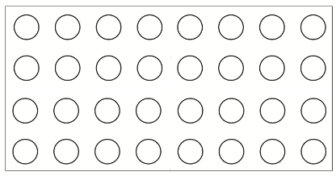
- If you put four 8 x 4 plates together to make one larger plate, what would the area of the large plate be?
8
8
4
4

Volume and Surface Area
CAPS alignment:

Phase | Grades | Content area | Topic
Intermediate Phase | Grade 4-6 | 4. Measurement | 4.6 Perimeter, surface area & volume
Senior Phase | Grades 7-9 | 4. Measurement | 4.2 Surface area & volume of 3D shapes

Rectangular Prism Investigation:

LEGO needed: A selection of different sized LEGO bricks for each student.

- Explain to the students that 3D shapes are shapes with length, breadth and height (i.e. three dimensions). Ask them if they can name some 3D shapes.

- Tell the student to see what 3D shapes they can make out of LEGO bricks and ask them to name the shapes. Most of the students will probably have built rectangular prisms or cuboids (they are not cubes unless the length, breadth and height are all the same)

- Ask the students to measure the length, breadth and height of their rectangular prisms. For lower grades, students can use the number of bricks and studs to measure the sides (i.e. assume that a 2 x 2 brick is 1 unit high and 2 units wide). For higher grades, students can measure the actual size of their shapes using rulers.

Investigation Continued (From Grade 7 only):

- When the students have finished measuring their shapes, give them theses formulae:
Surface Area = 2wl + 2lh +2hw

Volume = length x width x height

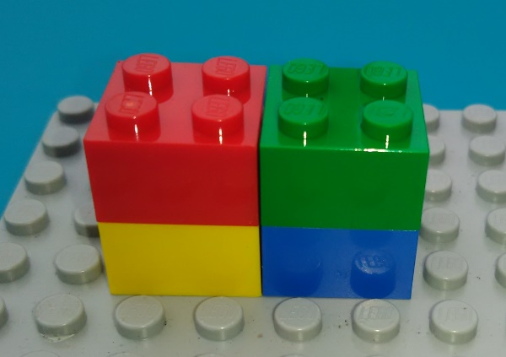
4
2
2
e.g. SA = 2wl +2lh + 2hw
= 16 + 16 + 8 = 40

V = l x b x h
= 4 x 2 x 2 = 16

5. Tell the students to use the formulae to work out the volume and surface area of their shapes.
6. Now ask them to work out the volume of one 2 x 2 brick

V = l x b x h = 2 x 2 x 1= 4

7. If you add one more 2 x 2 brick to the shape you built, what would the volume be then?

Cylinder Investigation (from Grade 9 only):

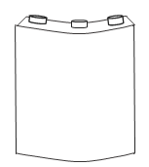
LEGO needed: Some quarter or half cylinder pieces, or some curved bricks that you could build into cylinders. If you don’t have any of these, then you can use old cool drink cans or other cylindrical household items instead.

- Get the students to build or find cylinders.

- Ask the students to measure the height of the cylinders and the diameter of the circle faces. They can do this using LEGO bricks or with rulers.

- Ask them to see if they can figure out formulae for the volume and surface area of a cylinder, and then use these to work out the volume and surface area of their cylinders.

- Give them these formulae:
Surface Area = $2πrh$ +$2πr^{2}$

Volume = $πr^{2}$ x height

4
e.g. $V= π4^{2} ×10=502.4{cm}^{3}$
$SA=2π4.10+2π4^{2}=351.68{cm}^{2}$

10

Data Handling
CAPS alignment:

Phase | Grades | Content area | Topic
Intermediate Phase | Grade 4-6 | 5. Data handling | 5.1 - 5.3 Collecting, organizing, representing & interpreting data
Senior Phase | Grades 7-9 | 5. Data handling | 5.1 - 5.3 Collecting, organizing, representing & interpreting data

LEGO needed: Baseplates and different coloured 1 x 1 and 2 x 2 of bricks or plates

- Transport bar graph: You can use this exercise to introduce data collection and bar graphs.
Note: There are two different ways to use bricks to build bar graphs. You can either build the bricks on top of one another or lay them flat (which is what we have used in this exercise). Feel free to choose which ever representation works best for you.

- Before the class, stick a 16 x 16 baseplate on to the bar graph template on the following page

- Ask the class how each of them travelled to school this morning

- For each mode of travel, pick a colour, and ask the students to find a 2x2 brick in the colour that represents the mode they travelled in, and pass it to the front of the class:

- Blue – Walk  - Red – Taxi  - Yellow – Car | - Green – Bicycle  - Black – Train  - White – Bus
- Place the bricks in different coloured columns on the baseplate and label the horizontal axis according to what each colour represents

- Stick the brick bar graph on to the board so that all the students can see it

- Explain to the students that what they have made is something called a bar graph. Ask the students if any of them have seen one of these before and, if so, where.

8

7

6

5

4

3

2

1

0
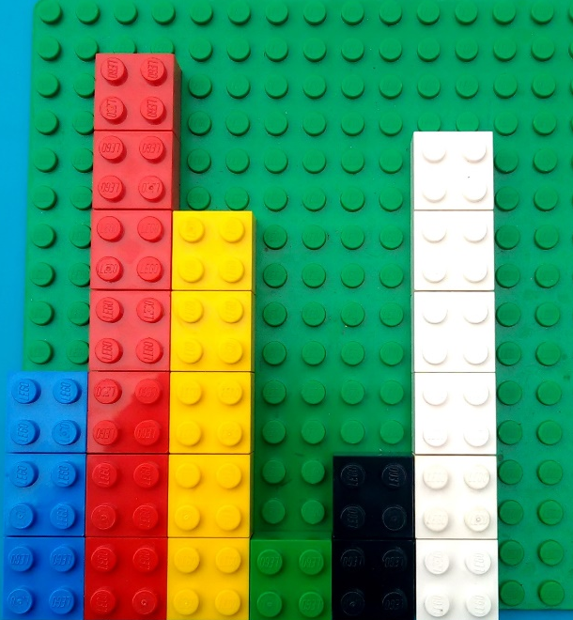
e.g. Ask the students:

- Which form of transport did the most people use today?

- Which form of transport did the least people use today?

- How many people came to school by bus?

- How many more people travelled by car than by train?

WALK
TAXI
CAR
BIKE
BUS
TRAIN

- Class data collection:

- Tell your students that they each need to choose a subject about which to collect data (from at least 10 classmates) and use it to build a bar graph

- Let the students have ten minutes to go round to their classmates and collect data by asking them a multiple choice question and recording their answers using a tally or table

- After they have collected their data, give each student a bar graph template and a baseplate

- Students label the axes and use LEGO bricks to build a bar graph on the baseplates

- Here are some examples of topics they could collect data on: Birth month, gender, birthplace, favourite colour, favourite TV show, favourite food, age, height. (Be careful not to choose topics that could cause students to feel discriminated against).

- Class broken line or scatter graph: You can use this exercise to introduce broken line graphs.

- Before the class, stick a 16 x 16 baseplate on to the line graph template and collect a set of data to write up on the board (e.g. class average over the last year)

- Explain to the class that you are going to be building a scatter graph together, and you will then change it into a broken line graph

- Scatter graphs and broken line graphs are often used to represent changes over time

- You are going to be building a graph which will show how their marks have changed over the year (you can make the graph about whatever you have collected data for)

- Tell the students to find 1 x 1 bricks, plates or studs in the LEGO

- Choose a few students to come and put a brick on a point on the baseplate to show how they would represent the data for a particular month

e.g.
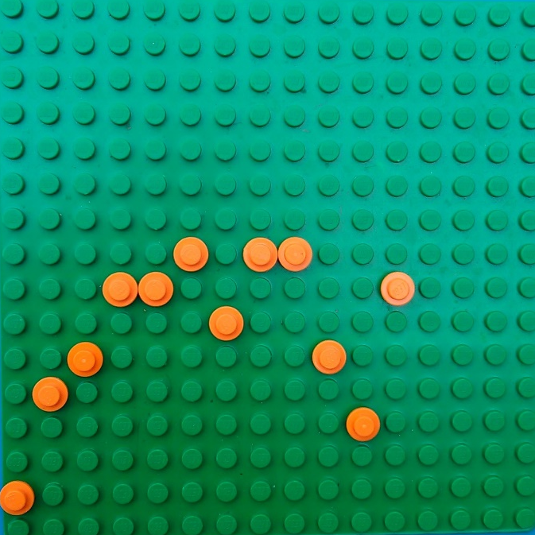
74

72

70

68

66

64

62

60

January
February
March
April
May
June
July
August
September
October
November
December

- Afterwards, discuss where they have placed their bricks and what they mean

- Explain that what they have just built is a scatter graph

- To turn the graph into a broken line graph, take piece of string and use it to join the bricks
Maths Game I: Twenty-Four
CAPS alignment:

Phase | Grades | Content area | Topic
Intermediate Phase | Grade 4-6 | 1. Numbers, operations & relationships | 1.1 Whole numbers  (Mental calculations)
Senior Phase | Grades 7-8 | 1. Numbers, operations & relationships | 1.1 Whole numbers  (Mental calculations)

LEGO needed: Baseplates and various sizes of bricks
Preparation: Before the class, prepare the game boards by placing four bricks on each baseplate. Make sure that the number of studs on the four bricks can be added, subtracted, multiplied or divided together to equal 24. If you want to make larger numbers than 8 and cannot find bricks for these, you can put two bricks together on the boards.

How the game works:
- Divide the students into groups of 2, 3 or 4
- Give each group a game board
- Students race to see who can get the four numbers (represented by the studs on the bricks) on the board to equal 24 using multiplication, division, addition or subtraction. Each number may only be used once.
- The first student to find a way to do so shouts “twenty-four” and then explains to the group how they would get to the answer. There may be multiple answers for some of the boards.
- When a group is finished with their board, they can exchange it for another one

Some examples:
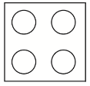
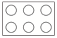
- (8 - 1 - 1) x 4 = 24
(8 + 4) x (1 + 1) = 24
(4 - 1) x 8 x 1 = 24

- (8 + 4) + (6 x 2) = 24
6 $÷$ (4 - 2) x 8 = 24

Maths Game II: Dice and Stack
CAPS alignment:

Phase | Grades | Content area | Topic
Intermediate Phase | Grade 4-6 | 1. Numbers, operations & relationships | 1.1 Whole numbers (Mental calculations)

Equipment needed: Two dice and thirty 2 x 4 LEGO bricks for each group
How the game works:
- Students play in groups of 4 – 6
- Students takes turns to throw two dice and then place two bricks on a communal build
- The sum of the numbers shown on the dice must be the number of studs that are left open on the top of the communal build
- The game begins with two bricks placed next to each other in the middle
- For example:
  - First student throws dice and they land on 4 and 3
  - First student takes two bricks and adds a new level to the bricks in the middle, leaving seven studs open
  - Second student throws dice and they land on 2 and 6
  - This student takes another two bricks and adds another level, leaving eight studs open
- When building each level, the students must keep the stack balanced so that it does not fall
- If a student cannot cover the studs correctly then he / she is out and the game continues with the remaining students

Maths Game III: Battleships
CAPS alignment:

Phase | Grades | Content area | Topic
Intermediate Phase | Grade 4-6 | 3. Space & shape (Geometry) | 3.6 Position and movement
Senior Phase | Grades 7-9 | 2. Patterns, functions & algebra | 2.2 Graphs

Equipment needed: Battleships grids (photocopy page) and 2 x 2 LEGO bricks of various colours
Alpha numeric version (Grades 4-6):
- Give each student a page with two alpha numeric battleships grids. Students play the game in pairs with a screen (e.g. an A4 book) set up between the two participants so that they cannot see one another’s grids.

- Students place 7 ships (coloured bricks in vertical or horizontal rows) on the grid on the left of the page, as shown in the example below. The ships may not touch sides with one another.
 | A | B | C | D | E | F | G | H
1
2
3
4
5
6
7
8
e.g.
Key:
Aircraft carrier – 5 bricks
Battleship – 4 bricks
Cruiser – 3 bricks
Destroyer – 2 bricks
Submarine – 1 brick

- Players take turns to guess the location of the ships on their opponent’s grid (1 block per turn) by giving the co-ordinates of one of the blocks (e.g. A3).
- The opponent announces whether each guess is a “hit” (i.e. there is a brick in the block guessed) or a “miss” (i.e. no brick in the block guessed) and removes any of their bricks that get hit. The other player uses the grid on the right to mark hits (red bricks) and misses (white bricks)

- When a complete ship has been hit, the opponent announces, “You sank my battleship”

- The winner is the first person to sink all of their opponent’s ships

Cartesian plane version (Grades 7-9):
- Give each student a page with two Cartesian plane battleships grids.

- The rules of the game are the same as in the previous version, except that students now call out the x-y co-ordinates of a square instead of the alpha numeric co-ordinates. The order in which they give the co-ordinates will indicate which is the x-value and which is the y-value (i.e. x first and then y), and so they may not use the terms x or y in describing their points. For example, to indicate the top left block of the grid below, a player would say: “-4, 4”.

e.g.
x
y
 |  |  |  | 4
 |  |  |  | 2
-4 | -3 | -2 | -1 | 1  1 | 2 | 3 | 4
 |  |  |  | -1
 |  |  |  | -2
 |  |  |  | -3
 |  |  |  | -4

Key:
Aircraft carrier – 5 bricks
Battleship – 4 bricks
Cruiser – 3 bricks
Destroyer – 2 bricks
Submarine – 1 brick

Mini version:

For an introductory lesson in the lower grades, or to aid with explanation if you are explaining the game to students in their second language, you can play the game on a smaller grid with just two or three ships to start with.

Maths Game IV: Brick Substitutions
CAPS alignment:

Phase | Grades | Content area | Topic
Senior Phase | Grade 8-9 | 2. Patterns, functions and algebra | 2.3 Algebraic expressions  2.4 Algebraic equations

Equipment needed: Dice, game board (photocopy page), minifigure parts and bricks
How the game works:
- Students play in groups of 2-4.

- Each player starts the game with one 2 x 4 brick, six 2 x 2 bricks, six 2 x 1 bricks and four 1 x 1 bricks, built together into a tower (which is then used as their game piece / counter). If you can find 1 x 3 bricks or 2 x 3 bricks in your box then you can include these too.

- Players begin in the top left-hand corner and take turns to play.

- On the first turn, players throw dice to see where they land.

- From the second turn onwards, the amount of blocks that a player moves is determined by the answer to the equation in the block that they are currently on.

- The letters in each equation are replaced by the number of studs on one brick (or two if there are two letters) which the player chooses from his or her tower.

- The player announces the answer to their equation and then moves that number of spaces forward (if the answer is positive) or backward (if the answer is negative). If the answer is between 0 and 1 (i.e. a fraction), the player moves 1 space back.

- If another player thinks the answer they have announced is incorrect, they may challenge them. If they are found to be incorrect, they move back to the original space and lose a minifigure part.

- After a player has used a brick in an equation, he/she removes it from their tower and places it in the centre of the game board (i.e. they may not use it again).

- Every time a player passes the top left-hand block, they collect a minifigure piece and build it on to their tower.

- The winner is the first player to build a complete minifigure (i.e. legs, body, head, hat and accessory).

e.g. Player lands on $y^{2}-10$ and chooses a 4 stud brick to represent y
Player substitutes the number 4 for y to make the equation: $4^{2}-10$
Player announces that the answer is 6 and moves their tower forward 6 spaces

Maths Game V: Shoot for a Shape
CAPS alignment:

Phase | Grades | Content area | Topic
Intermediate Phase | Grades 4 – 6 | 3. Space & shape (Geometry) | 3.1 Properties of 2D shapes
Senior Phase | Grades 7-9 | 3. Space & shape (Geometry) | 3.1 Geometry of 2D shapes

Equipment needed: Dice, beams & pins (or a selection of one stud wide plates or bricks) and shape cards (photocopy page). For more senior classes, you can make your own cards with just the names of the shapes on them (i.e. no pictures).

How the game works:
- Students play in groups of 2-4.

- Two or three cards are dealt (face down) to each player.

- Players look at their cards without showing them to anyone else.

- Each player needs to try and build the shapes on their cards.

- Each turn, a player throws two dice and then selects a beam or plate with the same number of holes or studs as the total on the dice. They may also select two or three smaller beams or plates whose holes or studs can be added together to equal the same number as was rolled. If there is no beam or combination of beams with the correct number of holes, then the player forfeits their turn.

- The first player to correctly build all of their shapes is the winner.

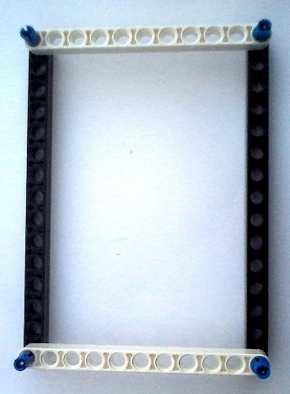
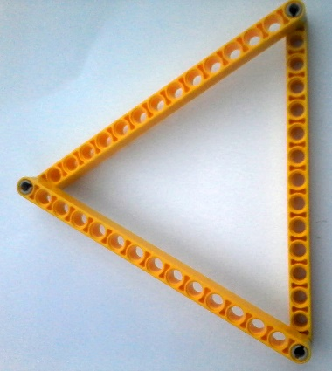
Equilateral Triangle
Rectangle

16 x 16 Baseplate Bar Graph Template

16 x 16 Baseplate Scatter Graph Template

Brick Battleships
Your Ships Enemy Ships

 | A | B | C | D | E | F | G | H | A | B | C | D | E | F | G | H
1
2
3
4
5
6
7
8

Aircraft Carrier – 5 bricks Battleship – 4 bricks Cruiser – 3 bricks
Destroyer – 2 bricks (x2) Submarine – 1 brick (x2)

Brick Battleships
Your Ships Enemy Ships
 |  |  |  |  |  |  |  | 4 |  |  |  |  |  |  |  |  |  |  |  |  |  |  |  |  | 4
 |  |  |  |  |  |  |  | 3 |  |  |  |  |  |  |  |  |  |  |  |  |  |  |  |  | 3
 |  |  |  |  |  |  |  | 2 |  |  |  |  |  |  |  |  |  |  |  |  |  |  |  |  | 2
 |  |  |  |  |  |  |  | 1 |  |  |  |  |  |  |  |  |  |  |  |  |  |  |  |  | 1
-4 |  | -3 |  | -2 |  | -1 |  | 0 | 1 |  | 2 |  | 3 |  | 4 | x | -4 |  | -3 |  | -2 |  | -1 |  | 0 | 1 |  | 2 |  | 3 |  | 4
 |  |  |  |  |  |  |  | -1 |  |  |  |  |  |  |  |  |  |  |  |  |  |  |  |  | -1
 |  |  |  |  |  |  |  | -2 |  |  |  |  |  |  |  |  |  |  |  |  |  |  |  |  | -2
 |  |  |  |  |  |  |  | -3 |  |  |  |  |  |  |  |  |  |  |  |  |  |  |  |  | -3
 |  |  |  |  |  |  |  | -4 |  |  |  |  |  |  |  |  |  |  |  |  |  |  |  |  | -4
y
y
x

Aircraft Carrier – 5 bricks Battleship – 4 bricks Cruiser – 3 bricks
Destroyer – 2 bricks (x2) Submarine – 1 brick (x2)

Your Ships Enemy Ships
Mini Brick Battleships
Cruiser – 3 bricks Destroyer – 2 bricks Submarine – 1 brick

Mini Brick Battleships
Cruiser – 3 bricks Destroyer – 2 bricks Submarine – 1 brick

 | A | B | C | D | E |  |  | A | B | C | D | E
1 |  |  |  |  |  |  | 1
2 |  |  |  |  |  |  | 2
3 |  |  |  |  |  |  | 3
4 |  |  |  |  |  |  | 4
5 |  |  |  |  |  |  | 5

y Your Ships y Enemy Ships
x
x
5 |  |  |  |  |  | 5
4 |  |  |  |  |  | 4
3 |  |  |  |  |  | 3
2 |  |  |  |  |  | 2
1 |  |  |  |  |  | 1
1 | 2 | 3 | 4 | 5 |  | 1 | 2 | 3 | 4 | 5
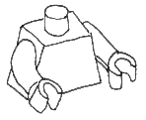
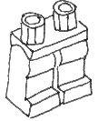
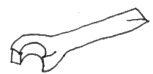
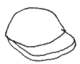
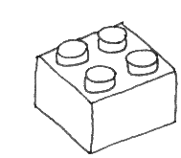
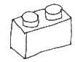
$$ab$$
$$2x+3y$$
$$\frac{x^{2}}{4}$$
$$20-3z$$
Pass GO and pick a minifigure piece!
$$4c-5$$
$$3a-c$$
$$3y$$
$$\frac{y^{2}}{2}$$

$${2a+2}^{3}+b$$
$$\frac{8y}{2z}$$
Say your 12 times tables correctly to 12 x 12 and move ahead 12 spaces
$$\frac{x}{2}$$
$$z(x-2)$$
Trade any brick with the person on your right & move forward 5 spaces
Brick Substitutions

- Each player starts the game with one 2 x 4 brick, six 2 x 2 bricks, six 2 x 1 bricks and four 1 x 1 bricks, built together into a tower (which is then used as their game piece / counter). If you can find 1 x 3 bricks or 2 x 3 bricks in your box then you can include these too.

- Players begin in the top left-hand corner and take turns to play.

- On the first turn, players throw dice to see where they land.

- From the second turn onwards, the amount of blocks that a player moves is determined by the answer to the equation in the block that they are currently on (i.e. no dice needed).

- The letters in each equation are replaced by the number of studs on one brick (or two if there are two letters) which the player chooses from his or her tower.

- The player announces the answer to their equation and then moves that number of spaces forward (if the answer is positive) or backward (if the answer is negative). If the answer is between 0 and 1 (i.e. a fraction), the player moves 1 space back.

- If another player thinks the answer they have announced is incorrect, they may challenge them. If they are found to be incorrect, they move back to the original space and lose a minifigure part.

- After a player has used a brick in an equation, he/she removes it from their tower and places it in the centre of the game board (i.e. they may not use it again).

- Every time a player passes the top left-hand block, they collect a minifigure piece.

- The winner is the first player to build a complete minifigure (i.e. legs, body, head, hat and accessory).

Lose your legs & move back 2 spaces
Choose any brick from the middle & move 1 space forward
Choose any brick from the middle & move 1 space forward

Isosceles triangle | Right-angled triangle | Rectangle | Square
Parallelogram | Trapezium | Pentagon | Hexagon
Equilateral triangle | Right-angled triangle | Rectangle | Square
Parallelogram | Rhombus | Pentagon | Hexagon

