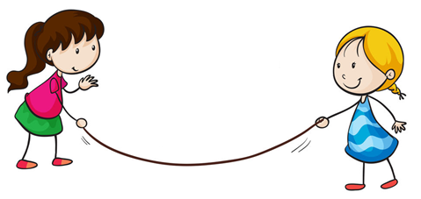

**LEGO**



**Play Box**

**Language**



Written in partnership with



**Contents:**

Teaching Language with LEGO ….2

Web links ….3

Naming the Bricks ….4

Build a Beginning ….5

Blind Build ….7

Listen and Build ….7

Add an Adjective ….8

Describe It ….8

Beginning, Middle, End ….9

Build a Rhyme ….9

Reading Relay …10

Minifigure Hangman …11

Build and Guess …11

Brick Instructions …12

Syllable Game …12

Understanding Metaphors …13

Five Brick Murder Mysteries …13

LEGO Words …14

Preposition Piles …16

Photocopy page: Build a Beginning …17

Photocopy page: LEGO Words …18

Photocopy page: Build and Guess …19

**Teaching Language with LEGO**

**An Introduction**

Why use manipulatives to teach language?

Manipulatives are concrete objects that students can see, touch and manoeuvre in order to model or show abstract concepts. Manipulatives are particularly helpful for teaching a second language and have been shown to increase comprehensibility and promote active involvement by the students. Manipulatives help to engage students in the learning and provide a fun way to teach and practice spoken and written language skills.

What LEGO pieces will I need to teach language?

The activities in this book are very flexible and most can be done with whatever pieces you have in your charity box. We suggest using mostly the minifigures and any other creative pieces you can find such as animals, food pieces, accessories etc., along with a few different sized bricks. You will also need to have a baseplate for each student to use, preferably of the same size.

What grades are these activities designed for?

These activities are designed for grades 4 -9. However, you can easily adapt them for a more or less advanced lesson for use at any grade level. We encourage you to use the activities in this book as a springboard for your own ideas.

Who is this book for?

This book has been designed for use by teachers who have received a LEGO charity box. There are a few photocopiable pages which can be used for some of the activities, but the rest of the content is for use by the teacher. The diagrams and pictures here are not intended to be photocopied and given to the students, as they can usually be replaced by 3D LEGO brick models (which are far more effective teaching tools) which you can build before the lesson and use as examples or demonstration models if needed.

Web links to (even more!) LEGO lesson ideas:

* https://education.lego.com/en-us/downloads/
  + Danny the Dazzling Dragon
  + The Witch in the Gingerbread House
  + The Rescue of Princess Amelia
* https://legoeducationuk.wordpress.com/category/lego-education-storystarter/
* https://education.lego.com/en-gb/lesi/elementary/storystarter/ss-instant-success
* http://www.tes.com/teaching-resource/
  + the-lego-movie-master-builders-6399854
  + lego-me-6429820
  + lego-sentence-building-eal-low-and-mixed-ability-6343499
  + speech-marks-and-dialogue-lego-movie-11055510
  + word-hoard-series-1-word-lego-prefix-and-suffix-11060047
  + lego-sentence-lengthening-writing-speaking-6342806
* http://www.teachingvillage.org/2010/05/27/more-than-five-things-to-do-with-lego-in-the-efl-classroom-part-2-by-emma-herrod/
* http://www.theguardian.com/teacher-network/2015/jan/13/five-ways-teachers-use-lego-creatively-class
* http://www.pleasantestthing.com/2013/07/reading-game-with-legos.html
* http://www.homegrownlearners.com/home/2013/4/1/lego-learning-language-arts-and-minifigs-download.html
* http://pinkandgreenmama.blogspot.co.za/2013/07/fun-with-legos-diy-lego-hangman.html
* http://www.kathysclutteredmind.com/2013/08/5-days-of-learning-with-legos-lego.html

**Naming the Bricks**

**An Introductory Lesson**

**Language skill:** Language structures and conventions (nouns and adjectives)

**LEGO needed:** A selection of different LEGO pieces

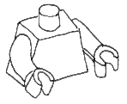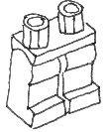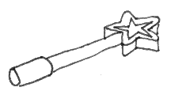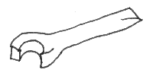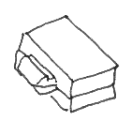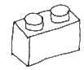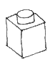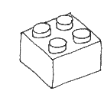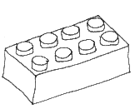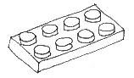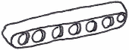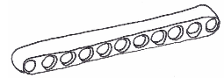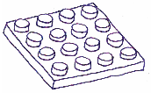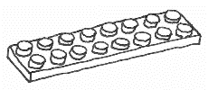

**Minifigure**

**Parts**

**Plates**

**Minifigure Accessories**

**Beams**

**Bricks**

**Wheels & Tyres**

**Exercise:**

* Introduce the students to the names of all the LEGO pieces
* Write all the words on the board e.g. brick, stud, plate, beam, legs, body, head
* Ask the students what kind of words these are (i.e. nouns)
* Now get the students to think of adjectives that they can use to describe the pieces and write a list of these words on the board e.g. thin, fat, long, short, green, blue, red, bumpy, round, hard
* 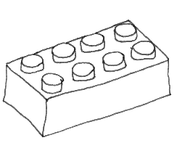Explain that we use the number of studs on the bricks to show which brick we are talking about (for example, a brick with 2 studs along the one edge and 4 studs along the other edge is called a two-by-four)
* Divide the students into groups of 3 or 4 and tell each group that they need to make up a song to help the class remember the name of that LEGO piece
* After they have come up with their songs, groups take turns teaching them to the class

**Build a Beginning**

**Language skill:** Writing

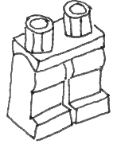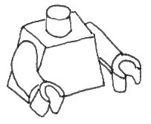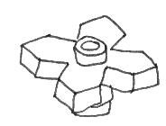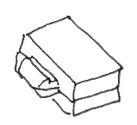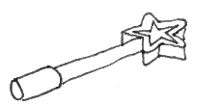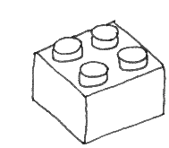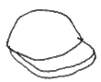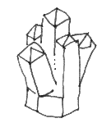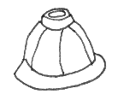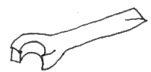**LEGO needed:** Give each student a baseplate and make sure that they all have access to a selection of creative pieces fromyour LEGO Charity Box (e.g. minifigure parts, minifigure accessories, flowers, flags, trees etc.) as well as some different sized bricks.

**Exercise:** Students build a 3D picture using creative LEGO elements, and then use what they have built to help them write a story.

**Some building ideas:**

* Choose 15 pieces and use these to build an animal
* Build a scene using only the colours you are wearing
* Build something fun you have done this week
* Choose 10 pieces with your eyes closed and then use these to build a scene
* Build two minifigures and put them on opposite ends of the baseplate. Build a path from one minifigure to the other using no more than 10 pieces.
* Use only red and blue pieces to build a scene
* Choose 10 pieces and then trade places with a friend and use their pieces to build a scene
* Build your dream for the future
* Imagine you are stuck on a desert island with only 3 things. Build it!
* Find all the pieces that begin with the letters A, B or C and use these to build a scene
* Use only green pieces to build a frog
* Find your favourite five LEGO pieces and use these to build something you love
* Build a scene from your favourite TV show or movie
* Build your first day of school
* Build a scene with your eyes closed
* Build a scene. Trade with a partner and move only five pieces to make it your own.
* 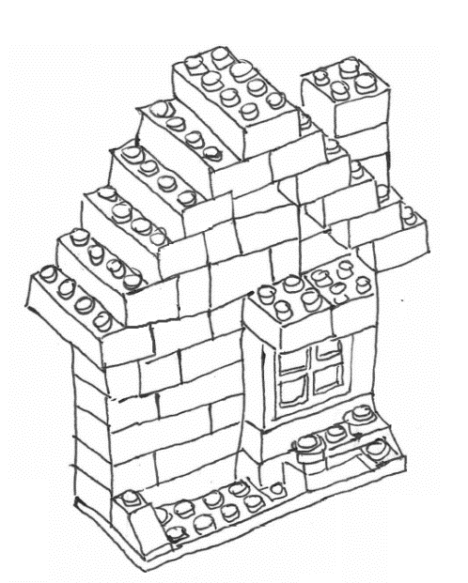Build a crazy machine
* Build a secret place
* Build a holiday
* Build a family
* Build a giant
* Build a bridge
* 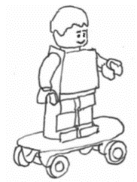Build an argument
* Build a map
* Build a journey
* Build something magical
* Build a happy scene
* Build an angry scene
* Build your biggest achievement



**Dice Game:**

* Divide the students into groups of 4 or 5
* Give each group a die, a box of LEGO pieces (like the ones described on the previous page) and a copy of the “Dice Game Key” on the following page. Give a baseplate to each student.
* Students take turns rolling the die and then taking a piece of LEGO from the box to use as part of a story they are building on their baseplate
* After each student has put 10 pieces on to their plate, the game finishes and the students use their scene to help them write a story

* For each number on the dice, the students are allowed to take a different kind of element:

1. A minifigure torso or legs
2. A minifigure head, hat or hair
3. Something a minifigure could hold in its hand
4. A plant or animal
5. A brick
6. Go wild! Choose whatever you like.

**Blind Build**

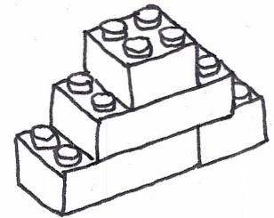**Language skill:** Listening and speaking

**LEGO needed:** A simple LEGO structure which you have built and hidden before the class, and a box or tray of LEGO for each group. Each group needs to have access to pieces matching the ones you have used to make your structure.

**Introduction:** Before playing the game, ask the class for examples of prepositions that they would use when describing something they have built out of LEGO bricks (e.g. underneath, below, on top of, next to) and write these on the board.

**Game:**

1. Divide the students in to groups of 2 or 3.
2. Tell each group to choose one person to be the “describer” and the rest to be “builders”.
3. Explain that you have a LEGO structure hidden behind a screen. The “describer” is the only person in the group who is allowed to come and look at the structure. They need to then go back to their group and describe what they have seen, and the group needs to try and build it. The “describer” may not touch the hidden structure or the LEGO their team is using. They may only communicate verbally.
4. When a group thinks they have completed the task, you can compare what they have built to the one behind the screen to see if it is the same. If it is not the same, ask the group what they need to change in order make it the same.

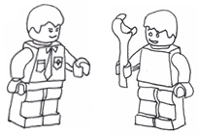**Listen and Build**

**Language skill:** Listening

**LEGO needed:** Give each student a baseplate and make sure that they all have access to a selection of creative pieces fromyour LEGO Charity Box as well as some different sized bricks.

**Explanation:** Read or tell a story or poem to the students. After you have finished, let the students build about what they have heard. Give a few of the students a turn to show and explain what they have built to the class

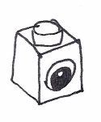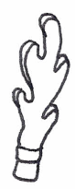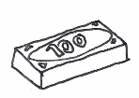**Add an Adjective**

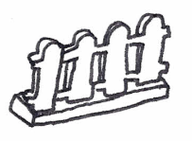**LEGO needed:** Give each student a baseplate and make sure that they all have access to a selection of creative pieces fromyour LEGO Charity Box as well as some different sized bricks.

**Game:**

1. Choose a theme that your class has been learning about recently.
2. Ask the students to build a person, place or object from that theme using just five LEGO pieces.
3. Students work with a partner, taking turns to guess what their partner has built.
4. After each incorrect guess, the student who built the model must add one “adjective” piece to their model that will help their partner to guess what it is. Explain that an adjective is a word that helps to describe a noun. The person, place or object is the noun and the piece they are adding.
5. The game ends when one of the students has guessed what their partner’s model is or both partners have had three incorrect guesses.
6. After the game, get the students to show the class what pieces they used as “adjectives” and write a list of all of these words on the board.

**Describe It**

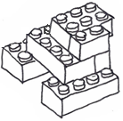**Language skill:** Speaking and listening

**LEGO needed:** A selection of different LEGO pieces

**Exercise:**

* Two students sit back to back
* One student builds a simple model out of 5 or 6 LEGO pieces
* This student then describes the structure to their partner, who needs to try and build the same model without looking at the original
* When the second student has finished, both students turn around and compare models
* The students then trade roles and repeat the exercise again
* The next time you play the game with your class, you can increase the number of LEGO pieces

**Beginning, Middle, End**

**Language skill:** Writing

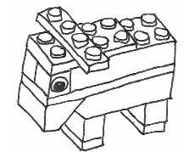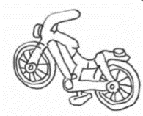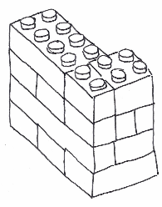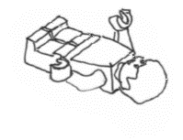**LEGO needed:** Give each student a baseplate and make sure that they all have access to a selection of creative pieces fromyour LEGO Charity Box as well as some different sized bricks.

**Introduction:** Explain that stories are usually written in three parts – a beginning, a middle, and an end. Talk about a story you have read as a class recently and ask the students what happened in the beginning, the middle and the end.

**Exercise:** Students work in groups of three. One person in the group builds the beginning of a story, one person builds the middle, and the third builds the end. When they have finished, each student uses the three scenes to write the beginning, middle and end of a story.

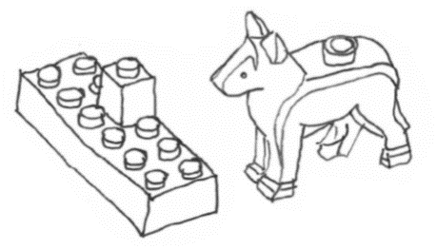**Build a Rhyme**

**Language skill:** Writing (poetry)

**LEGO needed:** Give each student a baseplate and make sure that they all have access to a selection of creative pieces and bricks

**Exercise:**

* Each student builds a model using just 10 LEGO pieces
* Explain that the class is going to be using their models to write a poem together
* The poem will have rhyming couplets (i.e. the word at the end of the first line needs to rhyme with the word at the end of the next line)

**e.g.** A dog walked up to a wall one day / He barked at the wall but it wouldn’t go away

* Go round the class and let each student take a turn at holding their model up and using what they’ve built (e.g. a tower) to add a line to the poem

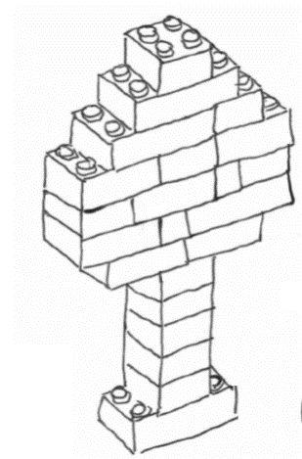**Reading Relay**

**Language skill:** Listening, speaking and reading

**LEGO needed:** A simple LEGO model which you have built and hidden before the class. Each team needs to have access to pieces matching the ones used to build your model.

**Preparation:** Write instructions of how to build your model and stick the instructions up on the wall.

**Game:**

1. Divide the students in to teams of 2 or 3.
2. Tell each team to choose one person to be the “reader” and the rest to be “builders”.
3. Explain how the game works:
   * A LEGO model has been built and hidden away
   * There is a list of instructions for the model stuck up on the wall
   * The reader is the only person in the group who is allowed to come and look at the instructions
   * They need to then go back to their group and relay what they have read, and the group needs to try and build it
   * The reader may only communicate verbally and may not touch the LEGO
   * The reader may go back and read the instructions as many times as they need to, but they may not shout to their team from the wall.
4. When a team thinks they have completed the task, you can compare what they have built to the model you have hidden to see if it is the same.
5. The winning team is the first team to complete the model correctly.

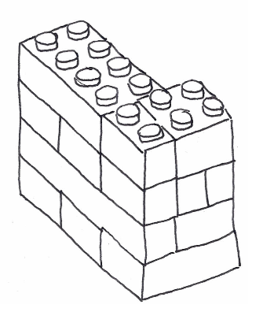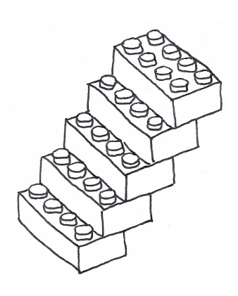

**Minifigure Hangman**

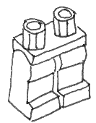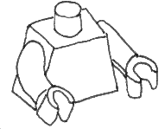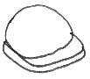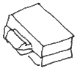

**Language skill:** Language structures and conventions (spelling)

**LEGO needed:** Minifigure parts (legs, bodies, heads, arms, hats and accessories)

**Game:**

* Play this game in two teams
* On the board, draw dashes to represent the number of letters in a word
* Have the players guess letters in the word, alternating between the teams
* If a letter in the word is guessed correctly, the teacher writes it into the correct space
* If a letter is guessed which is not in the word, the teacher adds a piece to that team’s minifigure
* The aim of the game is to guess the word before the minifigure has been completed

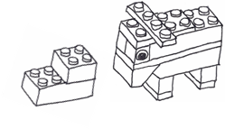**Build and Guess**

**Language skill:** Speaking and listening

**LEGO needed:** A box or tray of LEGO for each group.

**Game:**

1. Divide the students in to groups of 4 or 5.
2. Each student takes a turn to build something. The rest of their group tries to guess what they are building. The student who is building may not speak. When the group guesses correctly, the next student takes a turn to build something.
3. You can provide the names of the things that need to be built each round or you can let the students make up their own ideas.
4. If you want to turn the game into a competition, you can divide each group into two teams, and let them compete against each other. Teams take turns drawing a card (you can use the ones on the photocopy sheet or make your own) and then building what is written on the card for their teammates to guess. If their teammates guess the item correctly within the time limit, that team keeps the card. The winner is the team that has the most cards at the end.

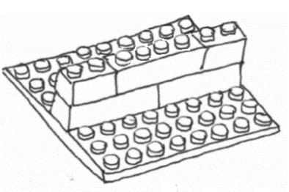**Brick Instructions**

**Language skill:** Reading and writing

**LEGO needed:** A selection of bricks and creative pieces for each group.

**Exercise:**

* Students work in groups of 2 or 3
* Each group builds a simple model out of LEGO (it may be necessary to limit the number of pieces they are allowed to use in their model, depending on how much time you have)
* The group then writes line-by-line instructions for how to build their model

**e.g.** *1. Put one green 1 x 4 brick on your baseplate.*

*2. Put a yellow 1 x 4 brick next to it so that the two bricks make a long wall.*

*3. Put a red 1 x 4 brick over the join of the first two bricks.*

* Once each group has written their instructions, they exchange instructions with another group
* Each group attempts to build the other group’s model using their instructions (the original models can be hidden away to prevent groups using the model rather than the instructions)
* Once, completed, each group compares their model with the original to see if it is correct

**Syllable Game**

**Language skill:** Language structures

**Preparation:** Write or type out a list of long words (in large font size), photocopy and cut out a set of words for each pair of students. Make sure that the word cards are different sizes (i.e.the word “accommodation” would be a long card and the word “marathon” would be on a shorter card).

**Game:**

1. Divide the students in to pairs.
2. Students place the word cards face down in front of them without looking at them.
3. One student points to a card and the other places a bet (i.e. a prediction of how many syllables they think the word will have) by placing a certain number of LEGO bricks on the table.
4. The first student turns over the card and then places one of the bricks above each syllable.
5. If the second student has guessed correctly, they keep the bricks. If they have guessed incorrectly, the other student keeps the bricks.

**Understanding Metaphors**

**Language skill:** Language structures and conventions (figurative language)

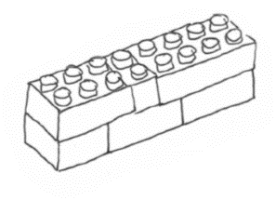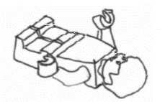

**LEGO needed:** All of the pieces

**Exercise:**

* Show the students the two pictures on the right and ask them which picture they think represents the word *strong* and which picture represents the word *weak.* Why?
* Next show the students a picture you have built and ask them to tell you what emotion they think it is showing and why. The aim of the exercise is to talk about how one picture can have various different meanings or interpretations.
* Explain that metaphors are used in language to compare one thing to another, in order to help to describe that thing e.g. the boy’s face was a river of tears. In the same way, we can use a picture to help describe something.
* Ask the students to build a metaphor which expresses how they are feeling today.

**Five Brick Murder Mysteries**

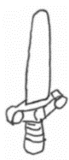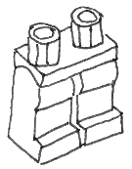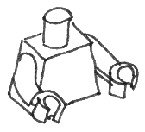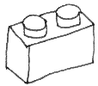

**Language skill:** Writing

**LEGO needed:** Baseplates, bricks, minifigures and accessories

**Exercise:**

* Divide students into groups of five and ask them to sit in a circle
* Each student choose one LEGO piece (as indicated below) to put on their baseplate and then passes the baseplate to the student on their left

Round 1: Minifigure body and legs Round 2: Minifigure head

Round 3: Brick Round 4: Object or accessory

**Police statement:**

* Murder suspect: *Name the minifigure*
* Motive: *Expression on the minifigure’s face*
* Murder weapon: *Object or accessory*
* Scene of crime: *Brick colour (e.g. blue - bathroom, red- kitchen)*
* Time of murder: *Number of studs on the brick*
* Students fill in a police statement like the one here and then use it to help them write a story:

**LEGO Words**

**Language skill:** Language structures and conventions

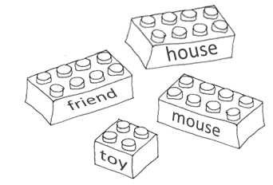**LEGO needed:** Two-by-two and two-by-four bricks

**Preparation:** Before the class, photocopy the following page so that you have a set of words for each student (or groups of students) in your class. Make sure you also have prestik or sticky tape for each student.

**Exercise 1 – Parts of speech:**

* Divide the students into groups of 2, 3 or 4 (depending on how many bricks you have) and give each group 60-80 different coloured two-by-two bricks and two-by-four bricks
* Students stick the different words on to different coloured bricks depending on which parts of speech they are. For example:
  + Nouns – Yellow
  + Verbs - Red
  + Adjectives – Blue
  + Prepositions – Green
  + Conjunctions – Black
  + Other – White
* After the students have stuck the words on the bricks, discuss their colour choices and show them the correct allocation by writing lists of the different parts of speech on the board

**Exercise 2 – Sentence building:**

* Students build sentences on baseplates using the brick words they made in the previous exercise
* Once a student has finished a sentence, they show it to the teacher to check that the sentence structure is correct
* If the sentence is correct, the student copies it on to a page or a book

**e.g.** *The boy builds a large house.*

**build**

**the**

**boy**

**a**

**-s**

**large**

**house**

* Remind the students to capitalise and use punctuation marks where needed when they write the sentences down
* After the students have each built 5-10 sentences, they can choose three of them and use them to write a paragraph

**Exercise 3 – Rhyming stacks:**

* Ask students if they can find any brick words that rhyme with one another (e.g. tall, ball, wall)
* Tell the students to build stacks of bricks that rhyme with one another

**Exercise 4 – Brick poetry:**

* Students build poems with rhyming couplets (i.e. the last words of every pair of lines should rhyme with one another) using the brick words created in exercise one
* The first line of the poem should be built on the baseplate
* The next line of the poem should be built on top of the first one, and so on
* You could have a competition to see who can build the tallest poem

**there**

**is**

**a**

**live**

**-s**

**a**

**in**

**he**

**house**

**is**

**very**

**small**

**strong**

**wall**

**but**

**has**

**a**

**it**

**mouse**

**large**

**Exercise 5 – Scene sentences:**

* Students work in pairs
* Each student builds a sentence on a baseplate using the brick words
* Students trade boards and then use some of the other LEGO pieces (e.g. minifigures, accessories) to try to build scenes that match their partner’s sentences
* They can also play the game the other way round (i.e. build scenes and then write sentences) but you may need to limit the LEGO pieces they use to build their scenes

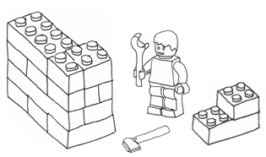

**

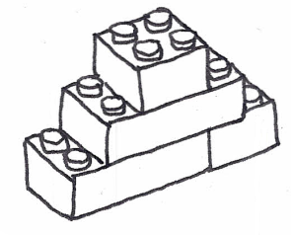**Preposition Piles**

**Language skill:** Language structures and conventions (prepositions)

**LEGO needed:** Different coloured bricks and baseplates

**Exercise:**

* Give each student six different coloured bricks and a baseplate
* Students build the bricks together in any way they want to and then trade models with a classmate
* Students use the prepositions in the box to fill in the blanks in the sentences below

**Preposition Box:**

next to on top of under

below behind

behind in front of above

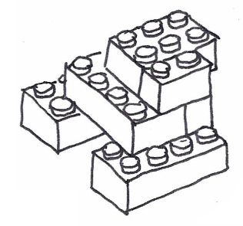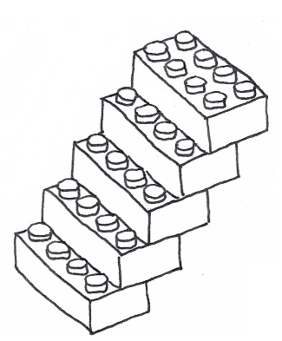

The red brick is ___________ the blue brick.

The yellow brick is ___________ the green brick.

The black brick is ____________ the white brick.

The red brick is ___________ the yellow brick.

The green brick is ___________ the black brick.

*Build a Beginning: Photocopy page*

**Dice Game Key**

Body or legs

Head, hair or hat

Something a person can hold

⚫

⚫

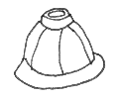

⚫

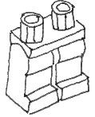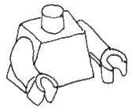

Plant or animal Brick You can choose!

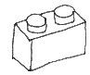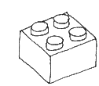

⚫ ⚫

⚫ ⚫

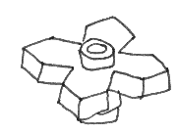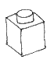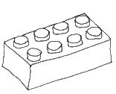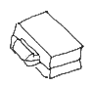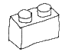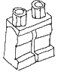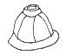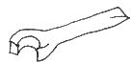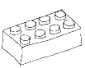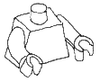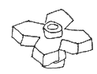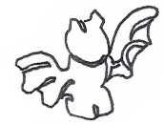

**Dice Game Key**

Body or legs

Head, hair or hat

Something a person can hold

⚫

⚫



⚫



Plant or animal Brick You can choose!



⚫ ⚫

⚫ ⚫



*LEGO Words: Photocopy page*

Cut these words out and stick them on to bricks with prestik or sticky tape:

|  |  |  |  |  |  |  |  |
| --- | --- | --- | --- | --- | --- | --- | --- |
| **love** | **mouse** | **lend** | **fight** | **boy** | **run** | **to** | **-s** |
| **throw** | **brick** | **build** | **make** | **it** | **his** | **he** | **-s** |
| **girl** | **climb** | **ball** | **wall** | **eat** | **her** | **my** | **a** |
| **tall** | **small** | **large** | **walk** | **are** | **she** | **am** | **I** |
| **friend** | **snake** | **bite** | **strong** | **toy** | **or** | **of** | **is** |
| **live** | **house** | **they** | **who** | **top** | **but** | **up** | **on** |
| **under** | **very** | **-ing** | **and** | **the** | **the** | **and** | **in** |
| **there** | **has** |  |  |  | **has** | **a** | **is** |

Cut these words out and stick them on to bricks with prestik or sticky tape:

|  |  |  |  |  |  |  |  |
| --- | --- | --- | --- | --- | --- | --- | --- |
| **love** | **mouse** | **lend** | **fight** | **boy** | **run** | **to** | **-s** |
| **throw** | **brick** | **build** | **make** | **it** | **his** | **he** | **-s** |
| **girl** | **climb** | **ball** | **wall** | **eat** | **her** | **my** | **a** |
| **tall** | **small** | **large** | **walk** | **are** | **she** | **am** | **I** |
| **friend** | **snake** | **bite** | **strong** | **toy** | **or** | **of** | **is** |
| **live** | **house** | **they** | **who** | **top** | **but** | **up** | **on** |
| **under** | **very** | **-ing** | **and** | **the** | **the** | **and** | **in** |
| **there** | **has** |  |  |  | **has** | **a** | **is** |

Use these to create your own word stickers:

|  |  |  |  |  |  |  |  |
| --- | --- | --- | --- | --- | --- | --- | --- |
|  |  |  |  |  |  |  |  |
|  |  |  |  |  |  |  |  |
|  |  |  |  |  |  |  |  |
|  |  |  |  |  |  |  |  |

*Build and Guess: Photocopy page*

|  |  |  |  |
| --- | --- | --- | --- |
| **house** | **dog** | **TV** | **chicken** |
| **bridge** | **car** | **spider** | **window** |
| **tree** | **piano** | **airplane** | **chair** |
| **phone** | **pool** | **flower** | **sun** |
| **oven** | **toilet** | **bed** | **table** |
| **cow** | **fence** | **bird** | **friend** |
| **carrot** | **stairs** | **pyramid** | **square** |
| **tall** | **short** | **giraffe** | **elephant** |